

GROUP ASSIGNMENT

**CT108-3-1-PYP**

**PROGRAMMING WITH PYTHON**

**APU1F2309SE**

**_________________________________________________________________________________**

|  |  |
| --- | --- |
| **BODHIDHARMA ONG** | **TP075444** |
| **GLENN CARLOS KHORIGIN** | **TP073664** |
| **REALXENG PANDELAKI** | **TP073374** |
| **STANLEY WIJAYA** | **TP073328** |

**DATE ASSIGNED : 17TH OCTOBER 2023**

**DEADLINE : 7TH JANUARY 2024**

**MODULE CODE : CT108-3-1-PYP**

**ASSIGNMENT : PYP GROUP ASSIGNMENT (DOCUMENTATION)**

**LECTURER : MS. SATHIAPRIYA RAMIAH**

Table of Contents

**Introduction and Assumptions 1**

**Design of the Program 2**

Bodhidharma Ong (TP075444) 2

login.py 2

admin.py 3

Glenn Carlos Khorigin (TP073664) 8

receptionist.py 8

Realxeng Pandelaki (TP073374) 11

student.py 11

Stanley Wijaya (TP073328) 18

tutor.py 18

**Explanation of Programming Concepts 23**

Bodhidharma Ong (TP075444) 23

Function 23

Stanley Wijaya (TP073328) 25

Selection 25

Glenn Carlos Khorigin (TP073664) 26

Condition 26

Realxeng Pandelaki (TP073374) 27

Looping 27

**Screenshots of sample input/output 29**

Login 29

Admin 29

Admin function 1: Register/delete tutors 29

Admin function 2: Register/delete the receptionist 34

Admin function 3: View the monthly income of a tutor 40

Admin function 4: Update admin’s own profile 41

Tutor 42

Tutor Function 1: Add Class Information 42

Tutor Function 2: Update/Delete Class Information 43

Tutor Function 3: View List of Student Enrolled in Your Subject 44

Tutor Function 4: Update Profile 44

Receptionist 46

Receptionist Function 1: Register a student 46

Receptionist Function 2: Update subject enrollment 47

Receptionist Function 3: Accept payment from students 48

Receptionist Function 4: Delete students who had completed their studies. 49

Receptionist Function 5: Update profile 50

Student 51

Student Function 1: View class schedule 51

Student Function 2: Request subject change 51

Student Function 3: Remove subject change request 53

Student Function 4: View payment status 55

Student Function 5: Update student data 57

**Conclusion 59**

**References 60**

# Introduction and Assumptions

Excellent Tuition Centre (ETC) is a tuition center in Kuala Lumpur providing coaching for secondary school students (Form 1 - Form 5) in subjects such as Bahasa Melayu (Malay Language), English Language, History, Mathematics, and Science. This center wanted to improve their business by having a program that could store information on their students and their subjects. In the program, ETC demands that there should be four types of users that could register into the system; those roles are Admin, Receptionist, Tutor, and Student. The center wants the program to have a login feature that requires the user to input their username followed by their password. The login page must only have a maximum of three attempts, the login page will exits if it exceeds that given limit for failed attempts. If the user logs in with the correct username and password they will be led to their menu option respectively according to their role.

To have such a program, our group programmed a simple program that mainly consists of 2 layers. The first layer is the login script (login.py) that demands the user to input a username and password. Based on the status that is assigned in the main database (main_database.txt) the user will be redirected to another script that corresponds to their roles (admin.py/receptionist.py/student.py/tutor.py), the user will be permitted to use the provided functions that will ask a few more inputs which will let them have the chosen function executed. Most of the scripts are written in the Python Language having “.py” at the end of each file name, for the databases that store information and are a result of multiple tests are in Text File Document format which has “.txt” at the end of each filename. Note that the starting of the program should begin with login.py, which could be run by typing $ python.exe login.py in the console terminal. For debug purposes, role-specified Python scripts (admin.py/receptionist.py/tutor.py/student.py) could be run individually and execute the same functionalities as long as the input is provided.

# Design of the Program

## Bodhidharma Ong (TP075444)

### login.py

Start

Set attempt_counter to 0

DOWHILE (attempt_counter < 3):

Display message "Attempt number" + (attempt_counter + 1)

Prompt user for username

Read username

IF (username == "exit") THEN:

Break from loop

ENDIF

Prompt user for password

Read password

IF (password == "exit") THEN:

Break from loop

ENDIF

attempt_counter = attempt_counter + 1

Open main database file for reading

Read all lines from the file

LOOP through each line in the file:

IF (username and password) are in line:

CASE OF status:

= "Admin": Run admin.py script, Exit the program

= "Receptionist": Run receptionist.py script, Exit the program

= "Tutor": Run tutor.py script, Exit the program

= "Student": Run student.py script, Exit the program

ENDCASE

ENDIF

ENDLOOP

End

### admin.py

Start

Function register_tutor(nm, lv, sj, ps):

IF (lv not in range 1 to 5) and (sj not in list of subjects) THEN:

Return without processing

ENDIF

Open main database for reading:

LOOP through each line in the file:

IF (nm in line) THEN:

Return without processing

ENDIF

ENDLOOP

Open main database for appending:

Write new record of tutor into main_database.txt

Close main_database.txt

Open tutor database for appending:

Write new record of tutor into tutor_database.txt

Close tutor_database.txt

Function delete_tutor(nm):

Open main database for reading:

Read through each line in the file

Open main database for writing:

LOOP through each line in the file:

IF (nm in line) THEN:

Do nothing

ENDIF

Write the lines

ENDLOOP

Close main_database.txt

Open tutor database for reading:

Read through each line in the file

Open tutor database for writing:

LOOP through each line in the file:

IF (nm in line) THEN:

Do nothing

ENDIF

Write the lines

ENDLOOP

Close tutor_database.txt

Function register_receptionist(nm, ps):

Open main database for appending:

Write new record of receptionist into main_database.txt

Close main_database.txt

Open receptionist_database for appending:

Write new record of receptionist into receptionist_database.txt

Close receptionist_database.txt

Function delete_receptionist(nm):

Open main database for reading:

Read through each line in the file

Open main database for writing:

LOOP through each line in the file:

IF (nm in line) THEN:

Do nothing

ENDIF

Write the lines

ENDLOOP

Close main_database.txt

Open receptionist database for reading:

Read through each line in the file

Open receptionist database for writing:

LOOP through each line in the file:

IF (nm in line) THEN:

Do nothing

ENDIF

Write the lines

ENDLOOP

Close receptionist_database.txt

Function view_monthly_income(nm, lv, sj):

Set subject_income = sj in income_report

Set level_income = lv * 1000

Calculate total_income = subject_income + level_income

Display nm, "monthly income: RM", total_income

Function change_profile(un, pw):

Open main database for reading:

Read through each line in the file

Open main database for reading:

LOOP through each line in the file:

IF (un in line) THEN:

Do nothing

ENDIF

Write the lines

ENDLOOP

Open main database for appending:

Write new record into main_database.txt

Close main_database.txt

Display a message to the admin with the available functions

Prompt user for admin_function

Read admin_function

IF (admin_function == 1) THEN:

Prompt user for register_or_delete

Read register_or_delete

IF (register_or_delete == "r") THEN:

Prompt user for tutor_name, tutor_level, tutor_subject, temporal_tutor_password

Call register_tutor(tutor_name, tutor_level, tutor_subject, temporal_tutor_password)

IF (register_or_delete == "d") THEN:

Prompt user for tutor_name

Call delete_tutor(tutor_name)

ELSE:

Display "Invalid input"

IF (admin_function == 2) THEN:

Prompt user for register_or_delete

Read register_or_delete

IF (register_or_delete == "r") THEN:

Prompt user for receptionist_name, temporal_receptionist_password

Call register_receptionist(receptionist_name, temporal_receptionist_password)

IF (register_or_delete == "d") THEN:

Prompt user for receptionist_name

Call delete_receptionist(receptionist_name)

ELSE:

Display "Invalid input"

IF (admin_function == 3) THEN:

Prompt for tutor_name, tutor_level, tutor_subject

Call view_monthly_income(tutor_name, tutor_level, tutor_subject)

IF (admin_function == 4) THEN:

Prompt for admin_username, admin_new_password

Call change_profile(admin_username, admin_new_password)

ELSE:

Display "Invalid input"

ENDIF

End

## Glenn Carlos Khorigin (TP073664)

### receptionist.py

Start

Import subjects from income_report

Function register_student(nm, ps, sjs, sd_i)

LOOP through each subject in sjs:

IF (subject not in ["Bahasa Melayu", "English Language", "History", "Mathematics", "Science"]) THEN:

Do nothing

ENDIF

ENDLOOP

IF (month not in ["January", "February", "March", "April", "May", "June", "July", "August", "September", "October", "November", "December"] or form not in range(1,6)) THEN :

Do nothing

ENDIF

Write new record of student into main_database.txt

Write new record of student to student_database.txt

Write new record of student to payment_status.txt

Function update_subject_enrollment(nm, n_sjs):

Open student database for reading:

Read through each line in the file

Set old_data_list as an empty list

LOOP through each line in the file:

IF (nm in line) THEN:

Append line into old_data_list

ENDIF

ENDLOOP

Set old_data_string as first string in old_data_list

Set subjects_section_start, subjects_section_end

Set new_data_string

Write new record into student_database.txt

Append into student_database.txt

Function accept_student_payment(nm, lv, sj1, sj2, sj3):

Open student_database.txt for reading:

Read through each line in the file

LOOP through each line in the file

IF (nm in line) THEN:

Calculate total price (Based on level, and chosen subject)

Prompt user for payment confirmation

Display for payment detail

Write new record into payment_status.txt

ELSE:

Do nothing

ENDIF

ENDLOOP

Function delete_student(nm):

Open main_database.txt for reading:

Read through each line in the file

Write new record to main_database.txt

Open student_database.txt" for reading:

Write new record to student_database.txt

Function change_profile(un, pw):

Open main_database.txt for reading:

Read through each line in the file

Write new record to main_database.txt

Append new record to main_database.txt

Display receptionist_message

Prompt user for receptionist_function

IF (receptionist_function == 1) THEN:

Prompt user for student_name, temporal_student_password

Set chosen_subject as empty list

Set inputted_subject_counter = 0

Display "List of subjects: Bahasa Melayu, English Language, History, Mathematics, Science"

DOWHILE (inputted_subject_counter < 3):

Prompt user for subject_choice

Append subject_choice to chosen_subject

Increment inputted_subject_counter by 1

ENDDO

Set student_infos as empty list

Prompt for ic_passport, email, contact_number, address, level, month_of_enrollment

Append ic_passport, email, contact_number, address, level, month_of_enrollment to student_infos

Call register_student(student_name, temporal_student_password, chosen_subjects, student_infos)

IF (receptionist_function == 2) THEN:

Prompt for student_name

Display "List of subjects: Bahasa Melayu, English Language, History, Mathematics, Science"

Set new_subject_counter = 0

Set new_subjects_list as an empty list

DOWHILE (new_subject_counter < 3):

Prompt user for new_subject

Increment new_subject_counter by 1

Append new_subject to new_subjects_list

Set new_subjects_string as the string of new_subjects_list

Call update_subject_enrollment(student_name.title(), new_subjects_string)

IF (receptionist_function == 3) THEN:

Prompt for student_name, student_level

Display "List of subjects: Bahasa Melayu, English Language, History, Mathematics, Science"

Prompt user for subject_1, subject_2, subject_3

Call accept_student_payment(student_name.title(), student_level, subject_1.title(), subject_2.title(), subject_3.title())

IF (receptionist_function == 4) THEN:

Prompt for student_name

Call delete_student(student_name)

IF (receptionist_function == 5) THEN:

Prompt for receptionist_username, receptionist_new_password

Call change_profile(receptionist_username, receptionist_new_password)

ELSE:

Display “Invalid input"

ENDIF

End

## Realxeng Pandelaki (TP073374)

### student.py

START

Function view_schedule(lv, sjs):

Open classes_database.txt for reading:

Read through each line in the file

Display “---Schedule---”

LOOP through each line in the file:

LOOP through each subject on sjs:

IF (“Form “, lv in line) AND (subject in line) THEN:

Display line

ENDIF

ENDLOOP

ENDLOOP

Function send_request(nm, sjs):

Open student_database.txt for reading:

Read through each line in the file

LOOP through each line in the file:

IF (nm not in line) THEN:

Do nothing

ENDIF

ENDLOOP

LOOP through each subject in sjs:

IF (subject is not in [“Bahasa Melayu”, “English Language”, “History”, “Mathematics”, “Science”]) THEN:

Do nothing

ENDIF

ENDLOOP

Open pending_requests.txt for reading:

Write new request of change into pending_requests.txt

Display “Request is sent, please wait for receptionist's update”

Function delete_request(nm):

Open pending_requests.txt for reading:

Read through each line in the file as lines

Open pending_requests.txt for writing:

LOOP through each line in the file:

IF (nm in lines) THEN:

Do nothing

ENDIF

Write line into pending_requests.txt

ENDLOOP

Function view_payment_status(nm, sjs):

Open payment_status.txt for reading:

Read through each line in the file as lines

LOOP through each line in the file:

IF (nm in lines) THEN:

Set payment_status_section_start, payment_status_section_end

IF (line[payment_status_section_start TO payment_status_section_end] is “Unpaid”) THEN:

TRY:

Calculate total_balance = subjects[sjs[0]] + subjects[sjs[1]] + subjects[sjs[3]]

EXCEPT:

Display “Invalid Subject(s)”

EXIT

Display “PAYMENT STATUS: Unpaid, TOTAL BALANCE DUE: RM “, total_balance

ELSE:

Display “PAYMENT STATUS: Paid”

ENDIF

ELSE:

Display “Name not in database”

ENDIF

ENDLOOP

Function change_profile(in, pw, sd_i):

Open main_database.txt for reading:

Read through each line in the file

Open main_database.txt for writing:

LOOP through each line in the file:

IF (un in line) THEN:

Do nothing

Write line into main_database.txt

ENDIF

ENDLOOP

Open main_database.txt for appending:

Write new record into main_database.txt

Open student_database.txt for reading:

Read through each line in the file

Initialize subject_list list

Open student_database.txt for writing:

LOOP through each line in the file:

IF (un in line) THEN:

Set subject_section_start, subject_section_end

Append line[subject_section_start TO subject_section_end] to subject_list

ENDIF

Write line into student_database.txt

ENDLOOP

Open student_database.txt for appending:

Write new record into student_database.txt

Display student_message

Prompt user for student_function

Read student_function

IF (student_function == 1) THEN:

Prompt user for student_level

Read student_level

Initialize student_subjects list

LOOP i FROM 1 TO 3 STEP 1:

Prompt user for prompt_subject

Append prompt_subject into student_subjects list

Next i

ENDLOOP

CALL view_schedule(student_level, student_subjects)

IF (student_function == 2) THEN:

Prompt user for student_name

Display ”Input existing/the same subject if that subject want to be kept”

Initialize student_subjects list

LOOP i FROM 1 TO 3 STEP 1:

Prompt user for prompt_subject

Append prompt_subject into student_subjects list

Next i

ENDLOOP

CALL send_request(student_name, student_subjects)

IF (student_function == 3) THEN:

Prompt user for student_name

CALL delete_request(student_name)

IF (student_function == 4) THEN:

Prompt user for student_name

Initialize student_subjects list

LOOP i FROM 1 TO 3 STEP 1:

Prompt user for prompt_subject

Append prompt_subject into student_subjects list

Next i

ENDLOOP

CALL view_payment_status(student_name, student_subjects)

IF (student_function) == 5 THEN:

Display ”Type the same information if you don't want to modify them.”

Prompt user for student_username, student_new_password

Initialize student_infos list

Prompt user for ic_passport, email, contact_number, address, level, month_of_enrollment

Append ic_passport, email, contact_number, address, level, month_of_enrolment into student_infos

CALL change_profile(student_username, student_new_password, student_infos)

ELSE:

Display “Invalid Input”

ENDIF

END

## 

## Stanley Wijaya (TP073328)

### tutor.py

Start

Function add_class_information(nm, sj, lv, sd, ss_s, ss_e):

IF (sj not in list of subjects) or (lv not in range 1 to 6) or (sd not in list of schedule) THEN:

Do nothing

ENDIF

Open classes database for appending:

Write new record of class into classes_database.txt

Close classes_database.txt

Function update_class_information(nm, sj, lv, sd, ss_s, ss_e):

IF (sj not in list of subjects) or (lv not in range 1 to 6) or (sd not in list of schedule) THEN:

Do nothing

ENDIF

Open classes database for reading:

Read through each line in the file

Open classes database for writing:

LOOP through each line in the file:

IF ( nm in line ) THEN:

Do nothing

ENDIF

Write the lines

ENDLOOP

Close classes_database.txt

Open classes database for appending:

Write new update of class into classes_database.txt

Close classes_database.txt

Function delete_class_information(nm):

Open classes database for reading:

Read through each line in the file

Open classes database for writing:

LOOP through each line in the file:

IF (nm in line) THEN:

Do nothing

ENDIF

Write the lines

ENDLOOP

Close classes_database.txt

Function view_list_of_students(lv, sj):

Open student database for reading:

Read through each line in the file

IF (lv not in range 1 to 6) or (sj not in list of subjects) THEN:

Do nothing

ENDIF

Initialize list_of_students as empty list

LOOP through each line in the file:

IF (lv in line) and (subject in line) THEN:

Locate start_of_name

Locate end_of_name

Set student_name = start_of_name until end_of_name

Append student_name into empty list of students

ENDIF

ENDLOOP

Close student_database.txt

Display "List of students enrolled :", list_of_students

Function update_profile(un, pw, lv, sj):

Open main database for reading:

Read through each line in the file

Open main database for writing:

LOOP through each line in the file:

IF (un in line) THEN:

Do nothing

ENDIF

Write the lines

ENDLOOP

Close main_database.txt

Open main database for appending:

Write new record of username and password for tutor

Close main_database.txt

Open tutor database for reading:

Read through each line in the file

Open tutor database for writing:

LOOP through each line in the file:

IF (un in line) THEN:

Do nothing

ENDIF

Write the lines

ENDLOOP

Close tutor_database.txt

Open tutor database for appending:

Write the update of username, level, and subject of the tutor

Close tutor_database.txt

Open classes database for reading:

Read through each line in the file

Open classes database for writing:

LOOP through each line in the file:

IF (un in line) THEN:

Do nothing

ENDIF

Write the lines

ENDLOOP

Close classes_database.txt

Display "Please add/modify class separately using the 1st/2nd function"

Display tutor_message

Prompt user for number

Read tutor_function

IF (tutor_function == 1) THEN:

Prompt user for tutor_name, subject_name, level_taught, weekly_schedule, session_start, session_end

CALL add_class_information( tutor_name, subject_name, level_taught, weekly_schedule, session_start, session_end )

IF (tutor_function == 2) THEN:

Prompt user for update_or_delete

IF (update_or_delete = "u") THEN:

Prompt user for tutor_name, subject_name, level_taught, weekly_schedule, session_start, session_end

CALL add_class_information( tutor_name, subject_name, level_taught, weekly_schedule, session_start, session_end )

IF (update_or_delete == "d") THEN:

Prompt user for tutor_name

CALL delete_class_information( tutor_name )

ELSE

Display "invalid input"

ENDIF

IF tutor_function == 3 THEN:

Prompt user for tutor_level, tutor_subject

CALL view_list_of_students( tutor_level, tutor_subject )

IF tutor_function == 4 THEN:

Display "Type the same information if info wasn't meant to be modified"

Prompt user for tutor_name, tutor_new_password, tutor_new_level, tutor_new_subject

CALL update_profile( tutor_name, tutor_new_password, tutor_new_level, tutor_new_subject )

ELSE:

Display "invalid input"

ENDIF

End

# Explanation of Programming Concepts

## Bodhidharma Ong (TP075444)

### Function

def register_tutor(nm, lv, sj, ps):

# Check if tutor level is between 1-5 and tutor subject in option or not

if lv not in range(1,6) or sj.title() not in ["Bahasa Melayu", "English Language", "History", "Mathematics", "Science"]:

return

# Check whether tutor had already existed in main_database.txt or not

with open("main_database.txt", "r") as md:

lines = md.readlines()

for line in lines:

if nm.lower() in line:

return

# Add the new tutor to main_database.txt

with open("main_database.txt", "a") as md:

md.write(f"\nUSERNAME: {nm.lower()}, PASSWORD: {ps}, STATUS: Tutor")

# Add the new tutor to tutor_database.txt

with open("tutor_database.txt", "a") as td:

td.write(f"\nTUTOR NAME: {nm.title()}, LEVEL: Form {lv}, SUBJECT: '{sj.title()}'")

*FIGURE 1.1: register_tutor function from admin.py (line 5-23)*

One of the most used programming concepts throughout the program is function. Function in brief is a block of code that will only run if it is called, the calling process of a function could include the passing of data known as parameters. As a result, a function can return data or print something in the end. Generally, there are two types of functions in Python, built-in functions that are provided by Python and functions that programmers define themselves. A function is usually created using the def keyword with the function name followed by a parenthesis beside it, the parentheses could be either empty or filled with arguments depending on how the function is meant to be used. Please understand that a defined function would only execute if called, just defining it won’t do anything. In Figure 1.1, the function register_tutor had multiple parameters inputted into the parenthesis (nm, lv, sj, ps) since those data are intended to be used for validity check & file processing (reading/appending data into .txt files) in the following lines below. Those very same parameters are determined by what sort of arguments are passed to the function when it is called like in Figure 1.2 where it is typed register_tutor(tutor_name, tutor_level, tutor_subject, temporal_tutor_password). What input is provided by the user into tutor_name, tutor_level, tutor_subject, temporal_tutor_password (as all of these three variables are input prompts) determines what will be processed in the function that is being called.

if admin_function == 1:

# Register/delete tutors

# Ask whether admin wants to register or delete a tutor

register_or_delete = input("Register (type R) or Delete (type D): ")

if register_or_delete.lower() == "r":

# Register a new tutor

# Prompt for tutor's name, level, subject, and temporal password

tutor_name = input("Tutor name: ")

tutor_level = int(input("Tutor level (1-5): "))

print("List of subjects: Bahasa Melayu, English Language, History, Mathematics, Science")

tutor_subject = input("Tutor subject: ")

temporal_tutor_password = input("Tutor temporal password (6-digits of number): ")

register_tutor(tutor_name, tutor_level, tutor_subject, temporal_tutor_password)

*FIGURE 1.2: Admin function 1 & register tutor selection (line 125-139)*

Note that the number of arguments passed into the calling of the function’s parenthesis must be within the same amount as the parameters inside of the actual function’s parenthesis. In a sense, (tutor_name, tutor_level, tutor_subject, temporal_tutor_password) in Figure 1.2 is a direct parallel of (nm, lv, sj, ps) in Figure 1.1. Python as a programming language doesn’t forbid programmers to type the same variable name for both actual function’s parameters and called function’s arguments, but it is a piece of common knowledge in the Python community to type a parameter as a generalized subject that refers to what the passed argument is. For example, tutor_name in the called function is referred to as nm in the actual function. Also, there is no rule as to what kind of data type could be passed into the argument of a called function. Those arguments could be a string, integer, float, list, etc.

## 

## Stanley Wijaya (TP073328)

### Selection

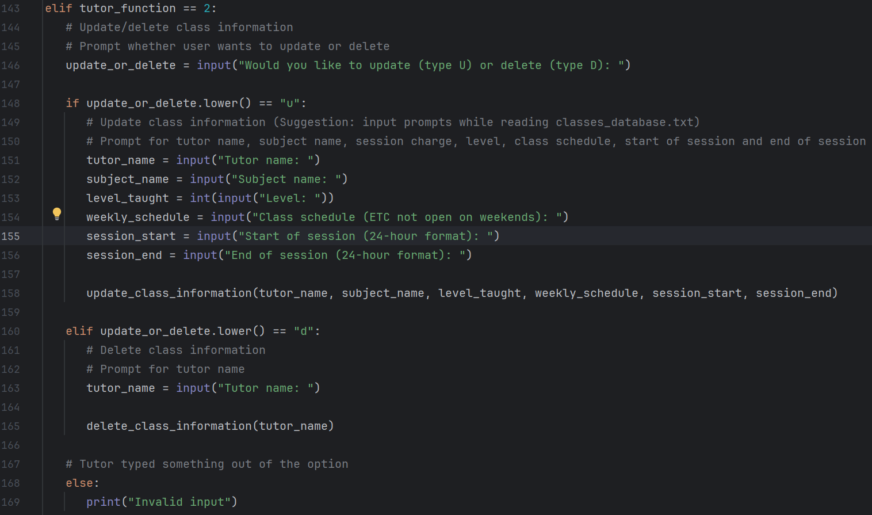

*FIGURE 2.1:Selection 2 & Subject input (line 143-169)*

Selection is a programming concept that helps programs to decide based on what the user entered or a prompt from the user, depending on the answer given by the user, the program will follow a certain step and leave the others till the program reaches the desirable outcome. Selection is implemented to the code with IF statements, it includes IF, ELIF, and ELSE. IF from the Figure 2.1 in line 148, is to decide what to do if the user inputted “u” then the program will prompt user for (tutor_name, subject_name, level_taught, weekly_schedule, session_start, and session_end) then it will continue with calling the function “update_class_information” and ELIF from the Figure 2.1 in line 160, is used for another condition as what to do if the user inputted “d” instead, the program will prompt the user for (tutor_name) and then will continue by calling the function “delete_class_information”, the last one is ELSE from Figure 2.1 in line 168, it is to display “invalid input” if the user input of “update_or_delete” in line 146 did not fulfill the IF and ELIF condition which is either “u” or “d” .

## Glenn Carlos Khorigin (TP073664)

### Condition

*FIGURE 3.1: register_student function from receptionist.py (line 5-25)*

Conditional statement is essential for controlling the flow of a code. It is used by computers to make decisions based on specific conditions. It implements Boolean expression to make decisions based on the truth value of the expression. In the code *(Figure 3.1)* conditions are set. As an example, code lines 7-9 check whether the inputted subject is or isn’t in the list of valid subjects. The same goes for code line 12-13 where it checks whether the inputted months and level is in the list of valid months and is in the range of 1 to 5. Both code sets conditions and register action in accordance with the input. Where if any condition is true, the function returns, which prevents the user from further processing the registration.

## Realxeng Pandelaki (TP073374)

### Looping

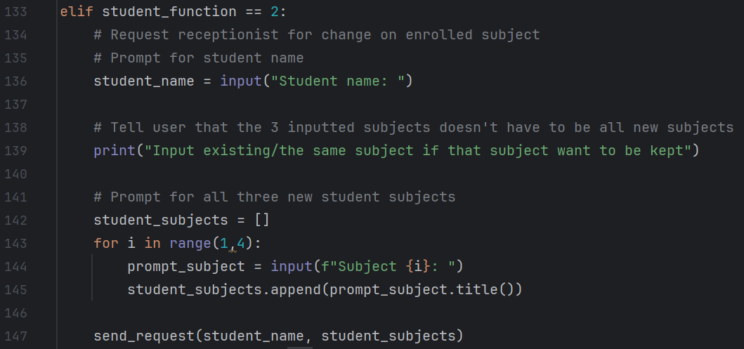

*FIGURE 4.1 Menu selection 2, and Subject input looping (line 133-147)*

Looping is an essential element in a program code. Its function is to continuously or repeatedly execute lines of instructions. It is there to minimize the number of execution lines the program has by not having to explicitly retype the same instruction when it is necessary to repeatedly run a sequence of code. There are two types of loops in Python. The first kind is a While loop. It is categorized as a condition-based loop as it will iterate the code provided that the condition stated is true. The other loop is called For loop. This loop is an interaction-based loop where the number of loops is determined explicitly in the code.

This snippet of code consists of looping for obtaining subject input from the student. For loop is used here due to the fact that the number of loops is pre-defined and the necessity to utilize its counting variable i to display which line of subject is being input. In this For loop, we ask the user for the intended subject and store it in the list. This will generate 3 lines of different subjects in the list (e.g. Mathematics, Science, English Language). This list is then transferred into the function parameter together with the student's name for identification.

Note that in the For statement (line 143), range(1,4) is used. The reason for this is that we are using the counting variable to show the line of subject as mentioned before. When we use a range starting with 0, in the first loop, the counting variable will still be 0, and 0 will be displayed in the subject counter. The usage of starting value 1 is to alter the value of the counting variable to start from 1 and thus when displaying in the first loop, the variable will hold the number 1 instead of 0. The second parameter is the upper limit. It is important that we understand the second parameter as the upper limit because the upper limit will not be counter. In this example, range(1,4) means the number from 1 to 3, and 4 is the upper limit hence is not included.

# Screenshots of sample input/output

## Login

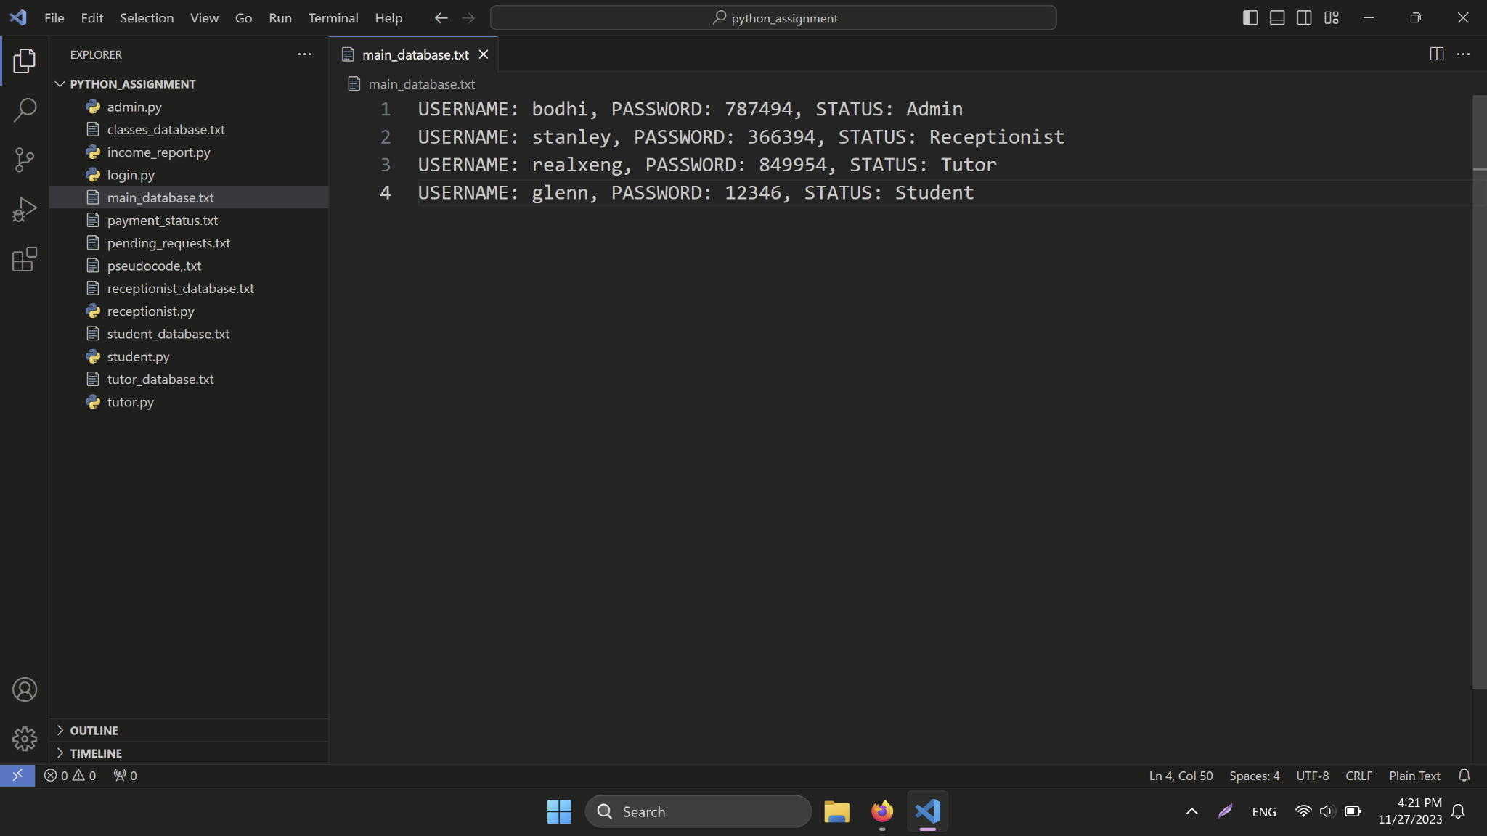

*FIGURE 5.1: main_database.txt*

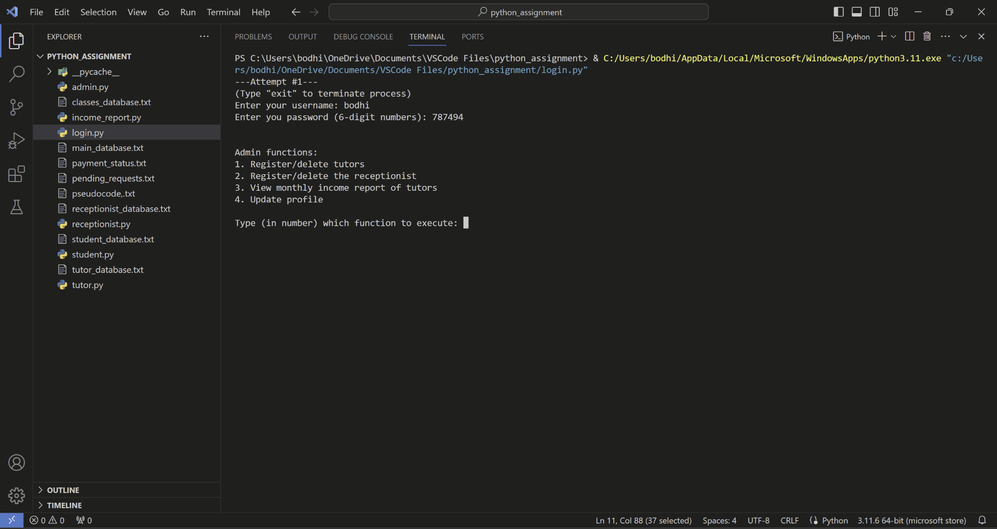

*FIGURE 5.2: run login.py, login as admin (Bodhi) as an example*

## Admin

### Admin function 1: Register/delete tutors

**Register a new tutor**



*FIGURE 6.1: main_database.txt before registering a new tutor*

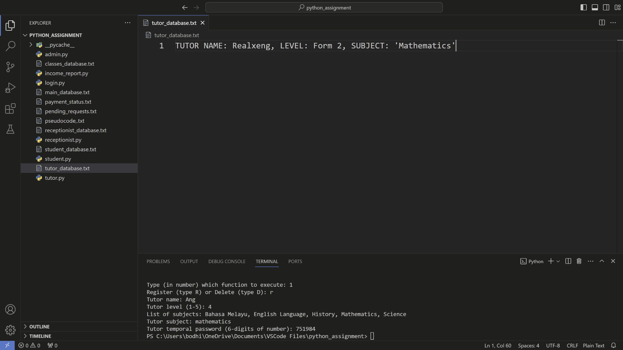

*FIGURE 6.2: tutor_database.txt before registering a new tutor*

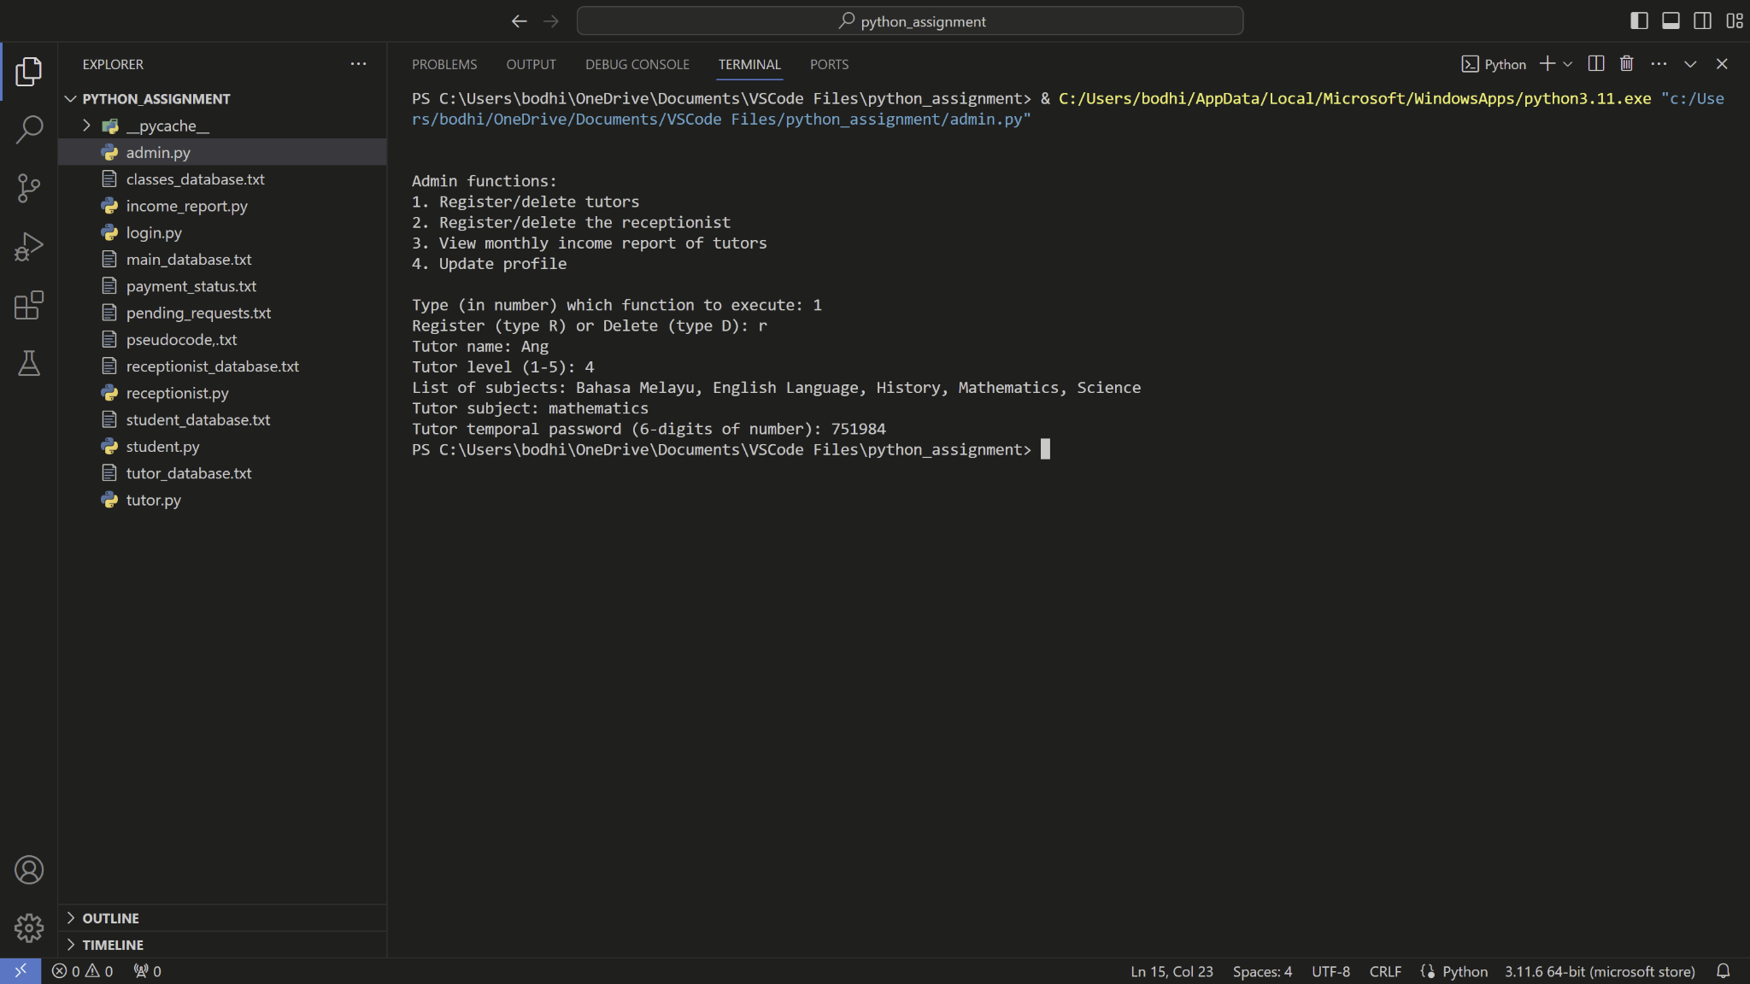

*FIGURE 6.3: run admin.py and use function 1, register a new tutor*

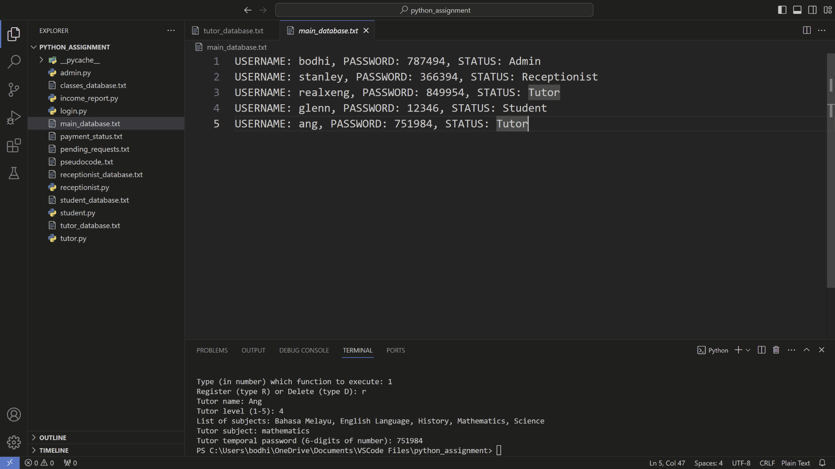

*FIGURE 6.4: main_database.txt after adding a new tutor*

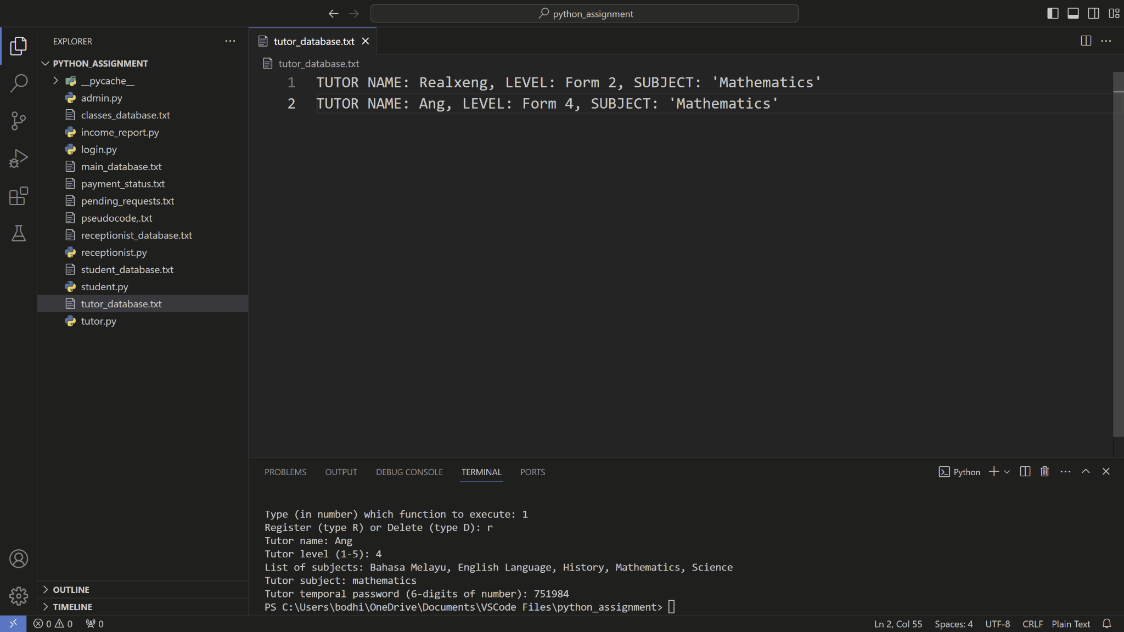

*FIGURE 6.5: tutor_database.txt after adding a new tutor*

**Delete a tutor**

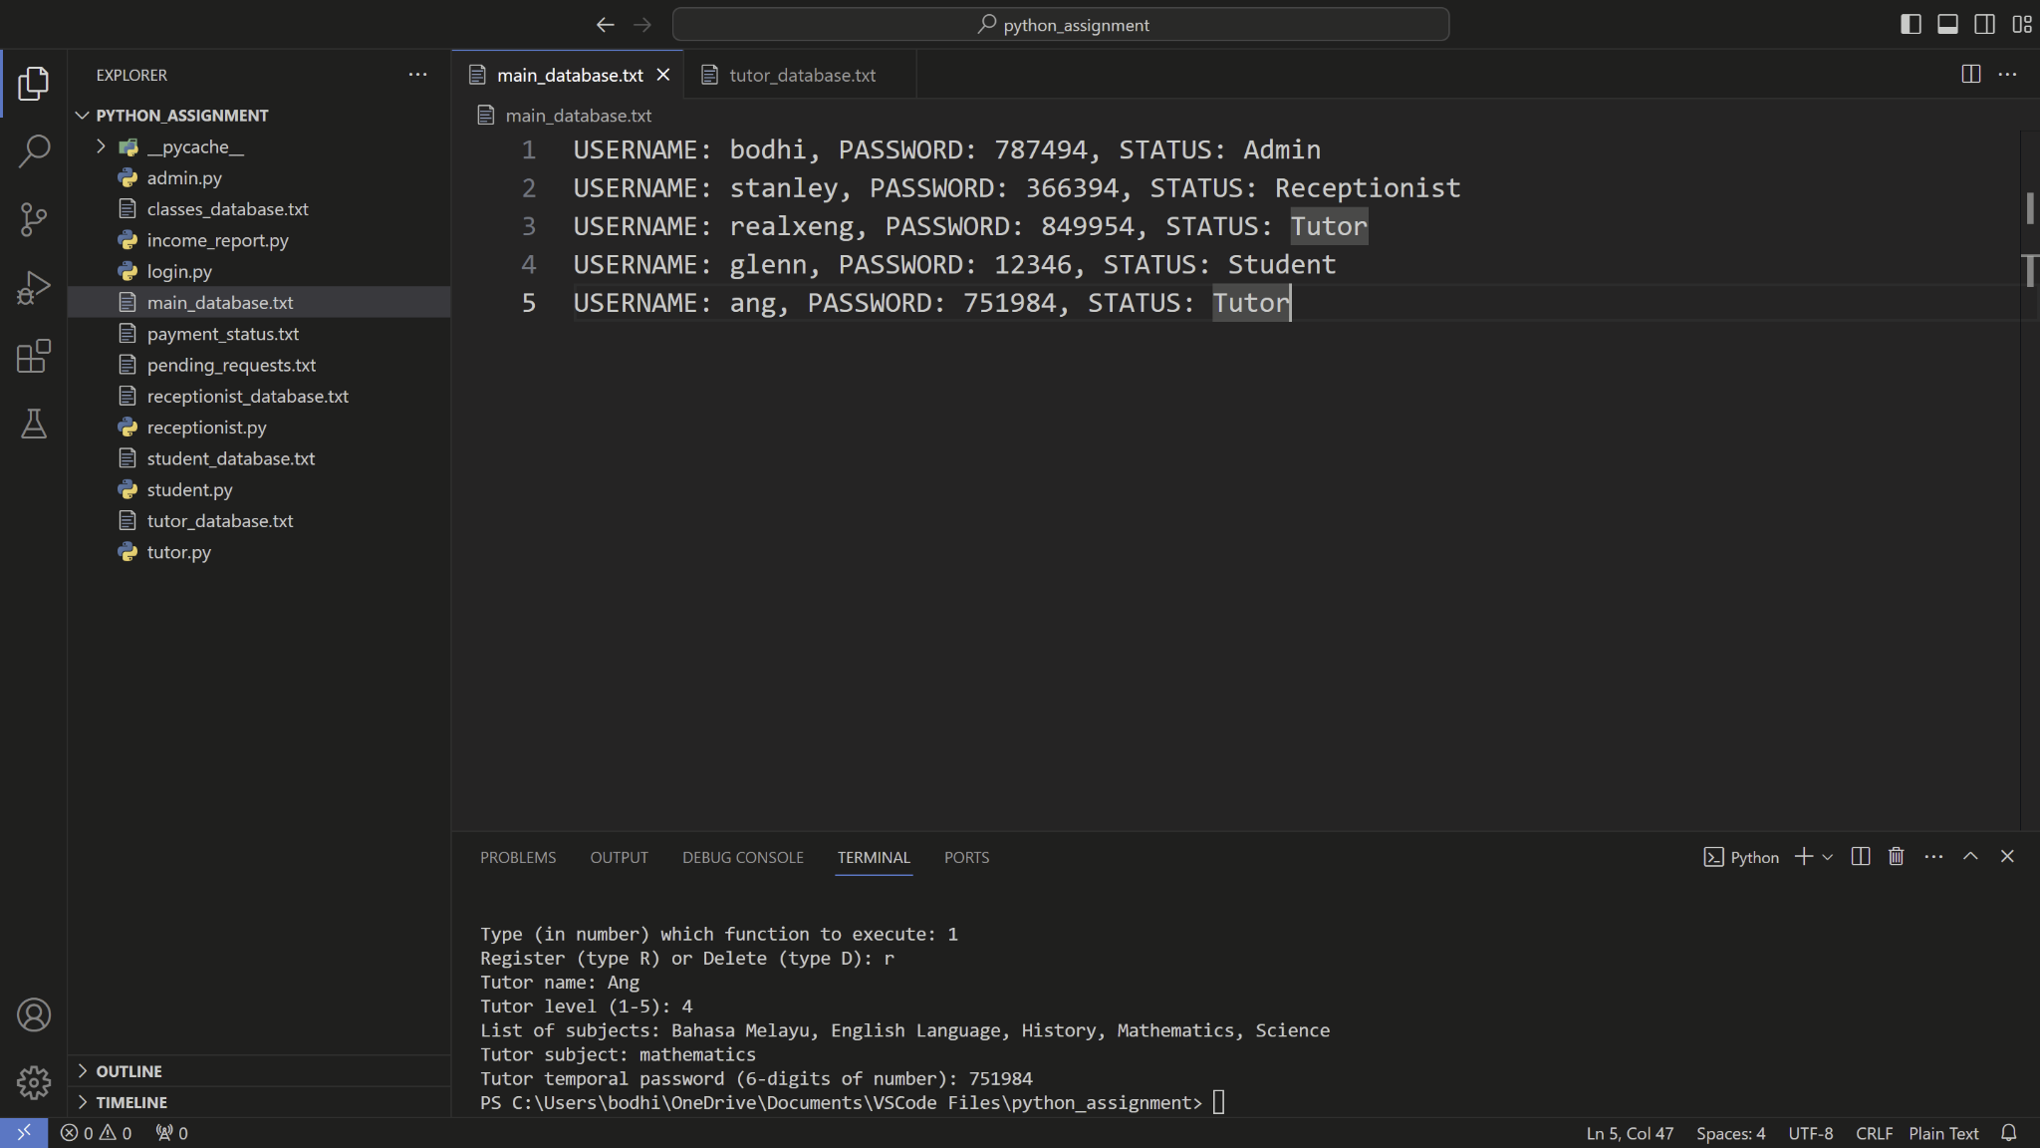

*FIGURE 6.6: main_database.txt before a tutor is deleted*

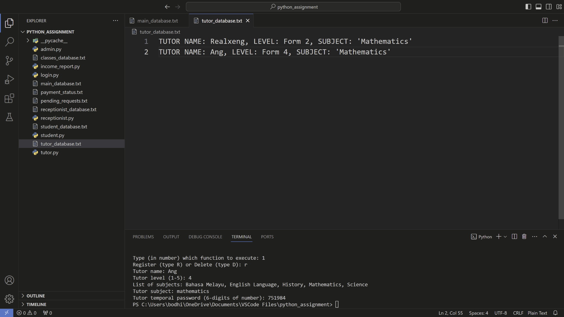

*FIGURE 6.7: tutor_database.txt before a tutor is deleted*

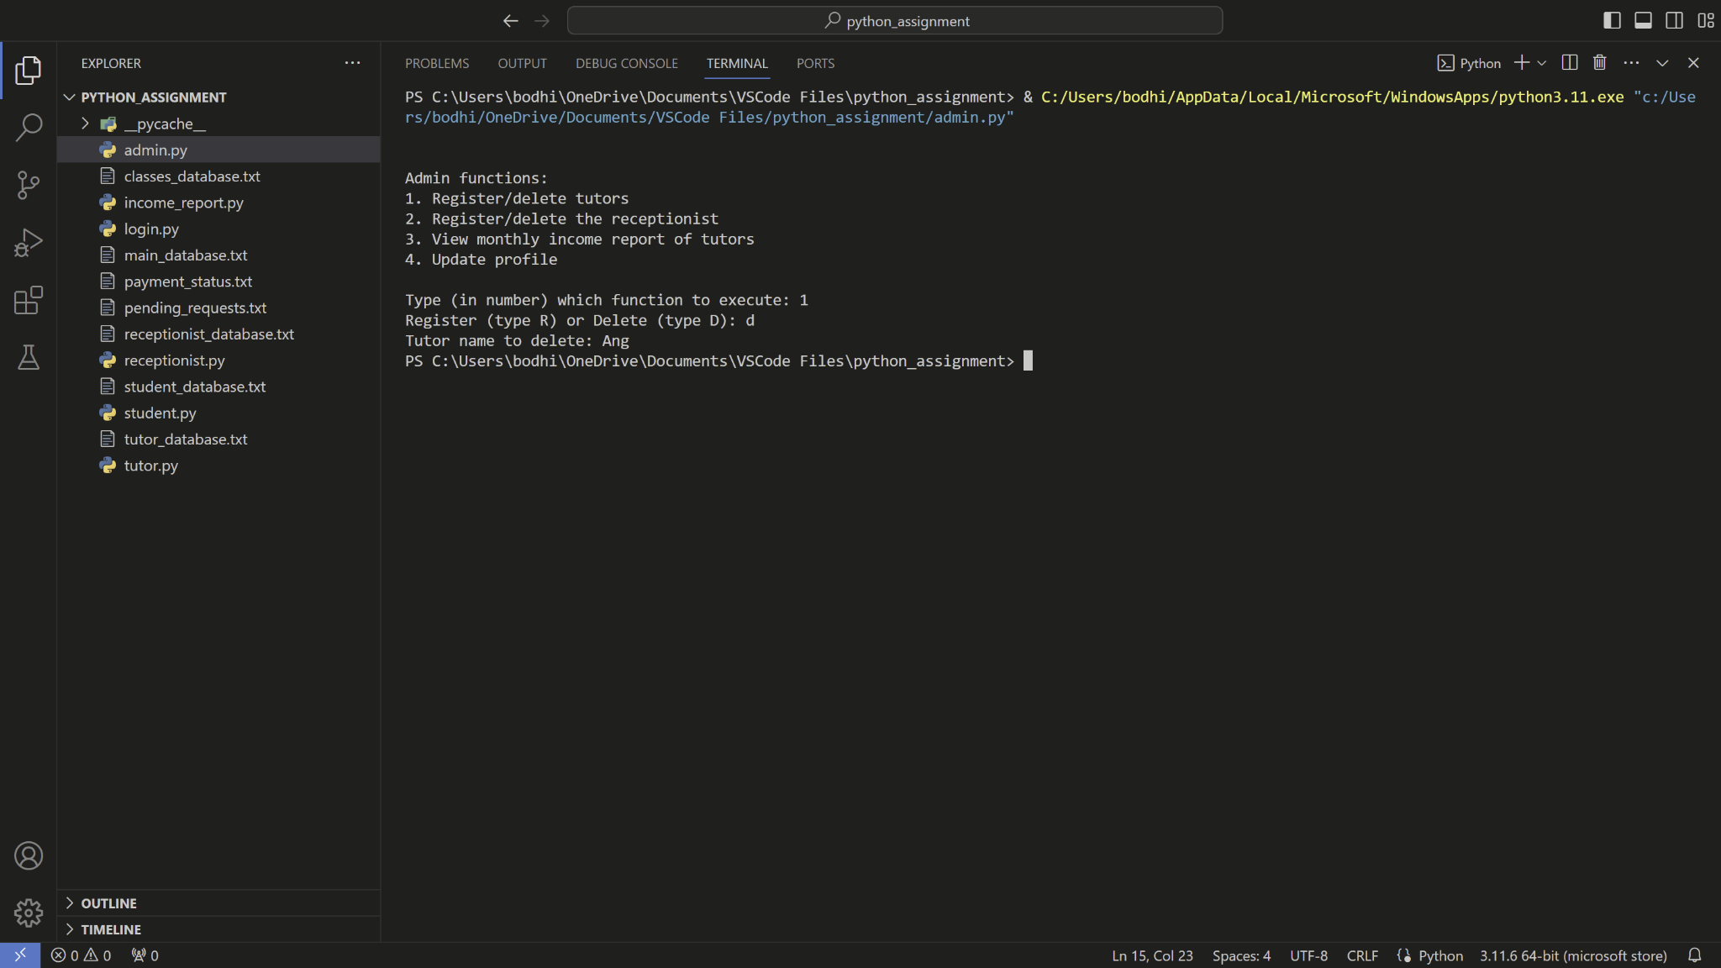

*FIGURE 6.8: run admin.py and use function 1, delete a tutor*

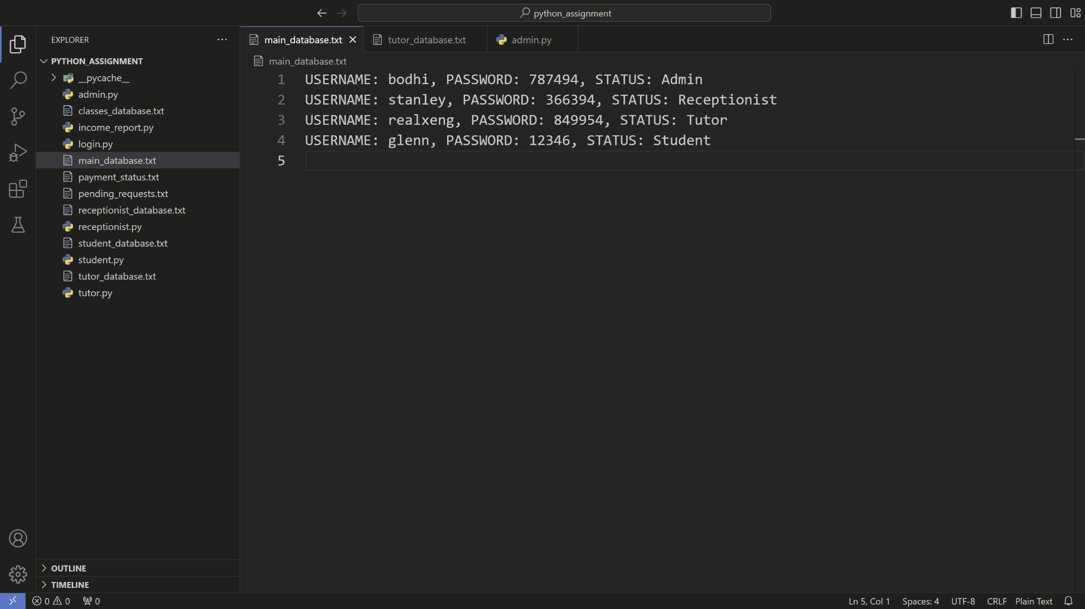

*FIGURE 6.9: main_database.txt after a tutor got deleted*

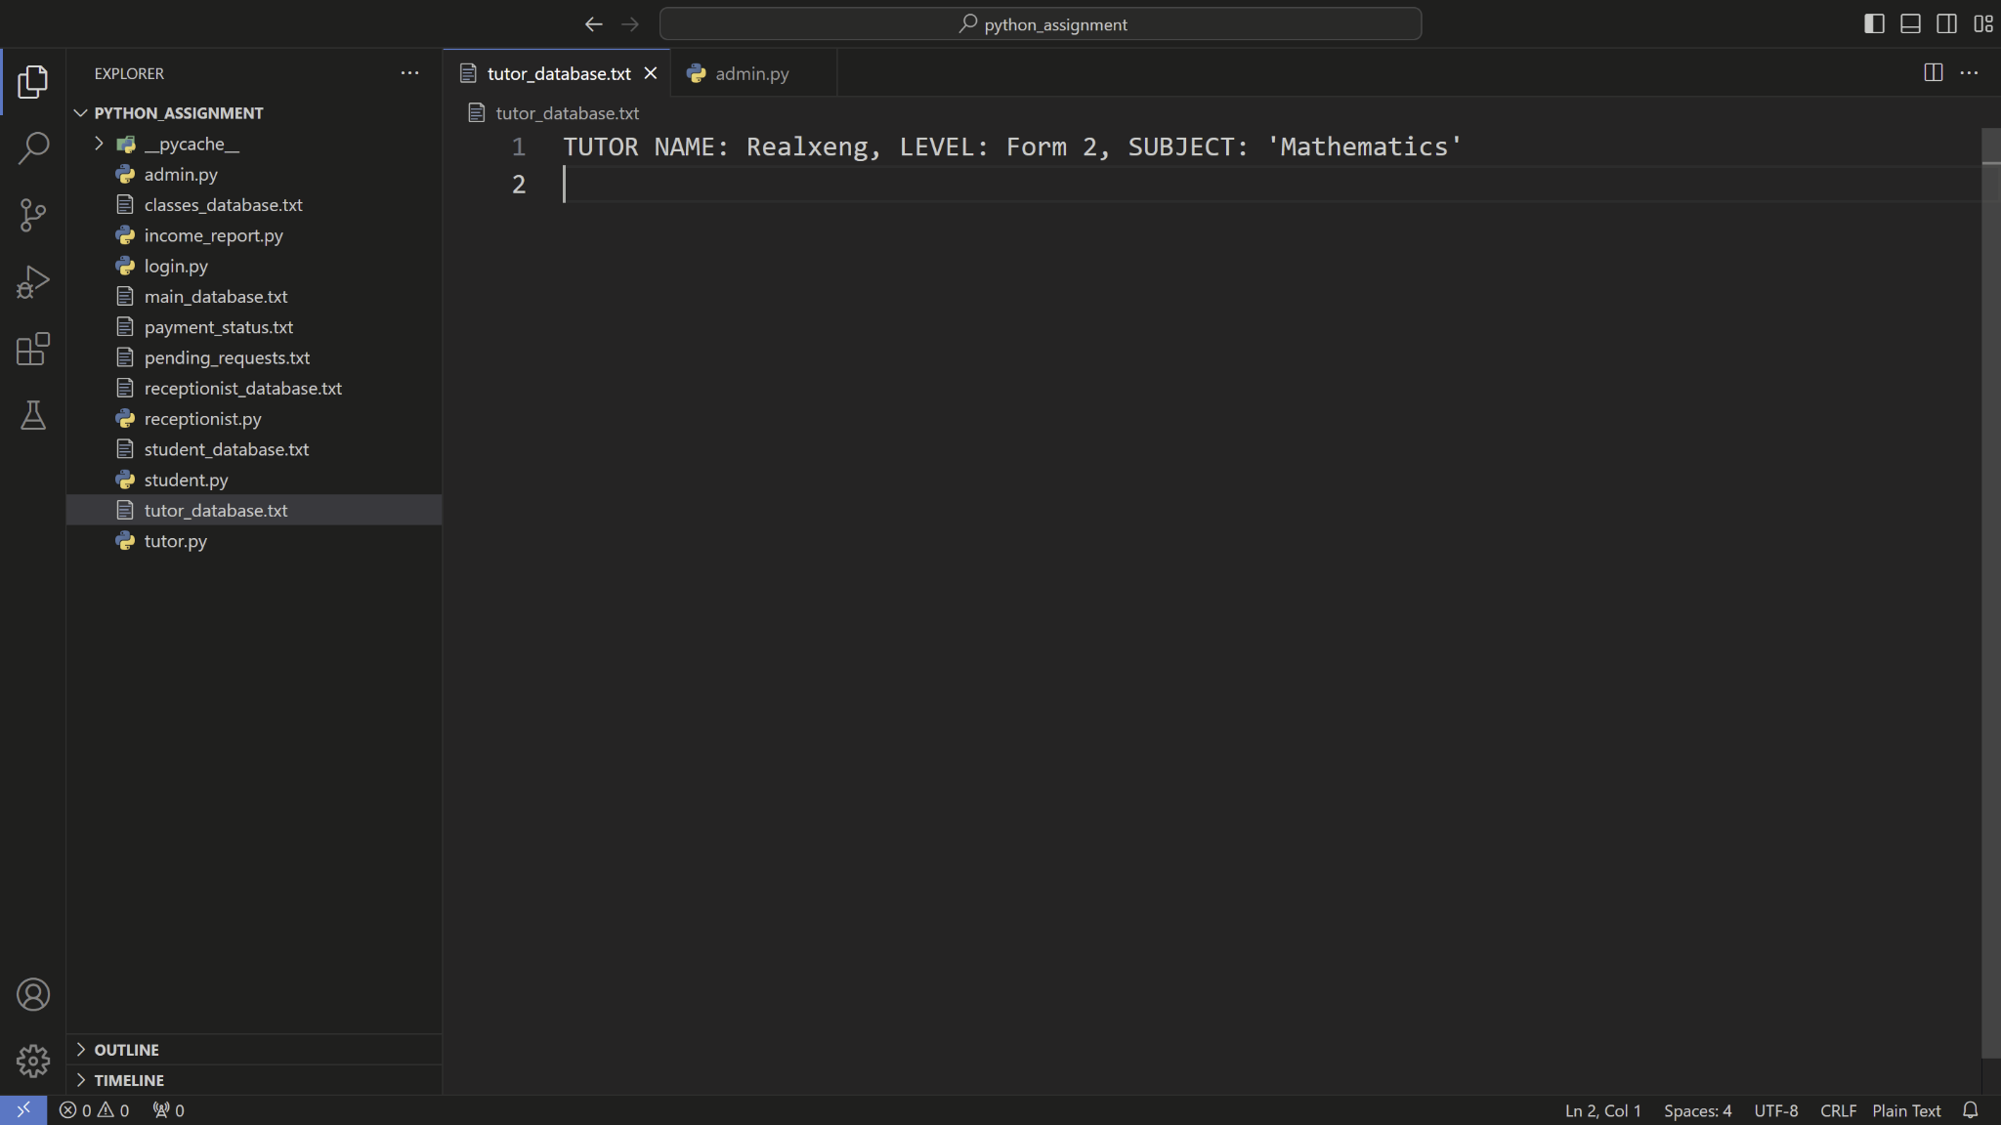

*FIGURE 6.10: tutor_database.txt after a tutor got deleted*

### Admin function 2: Register/delete the receptionist

**Register a new receptionist**

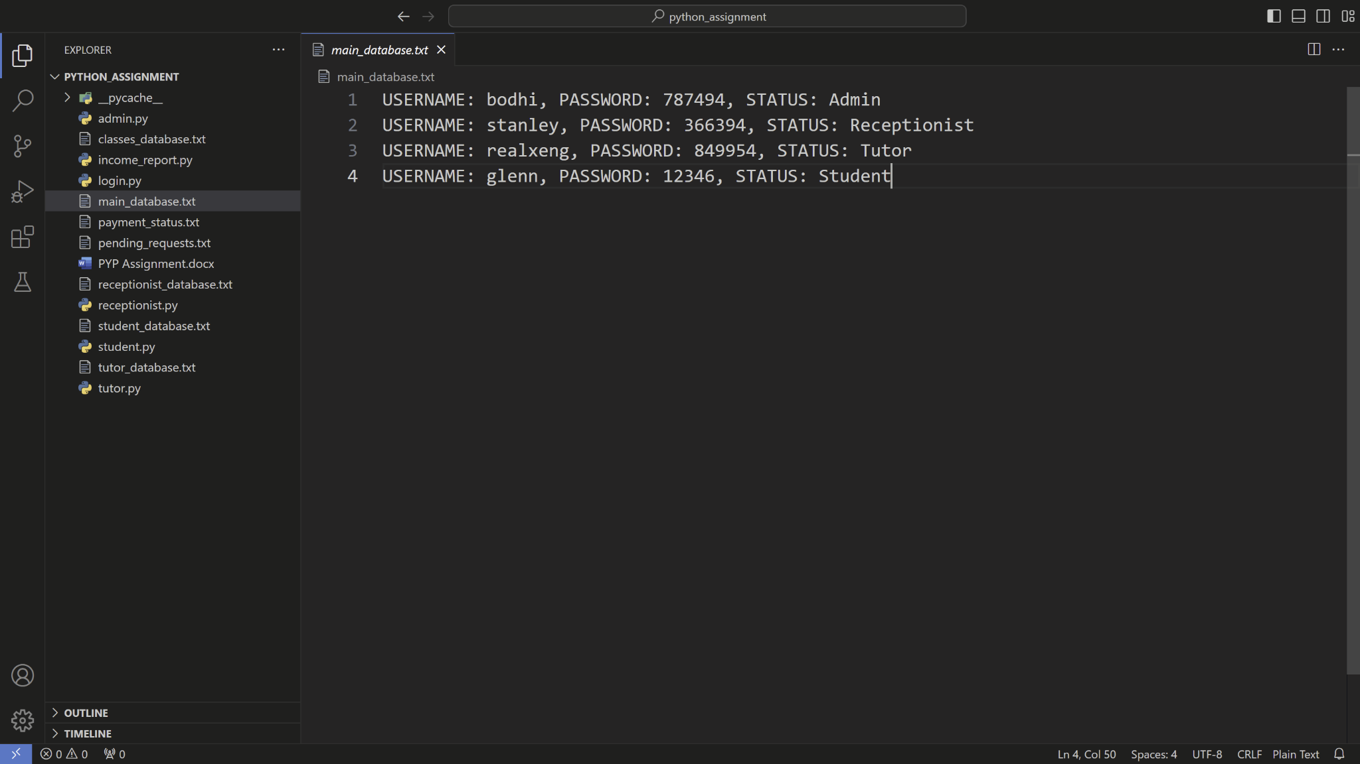

*FIGURE 7.1: main_database.txt before registering a new receptionist*

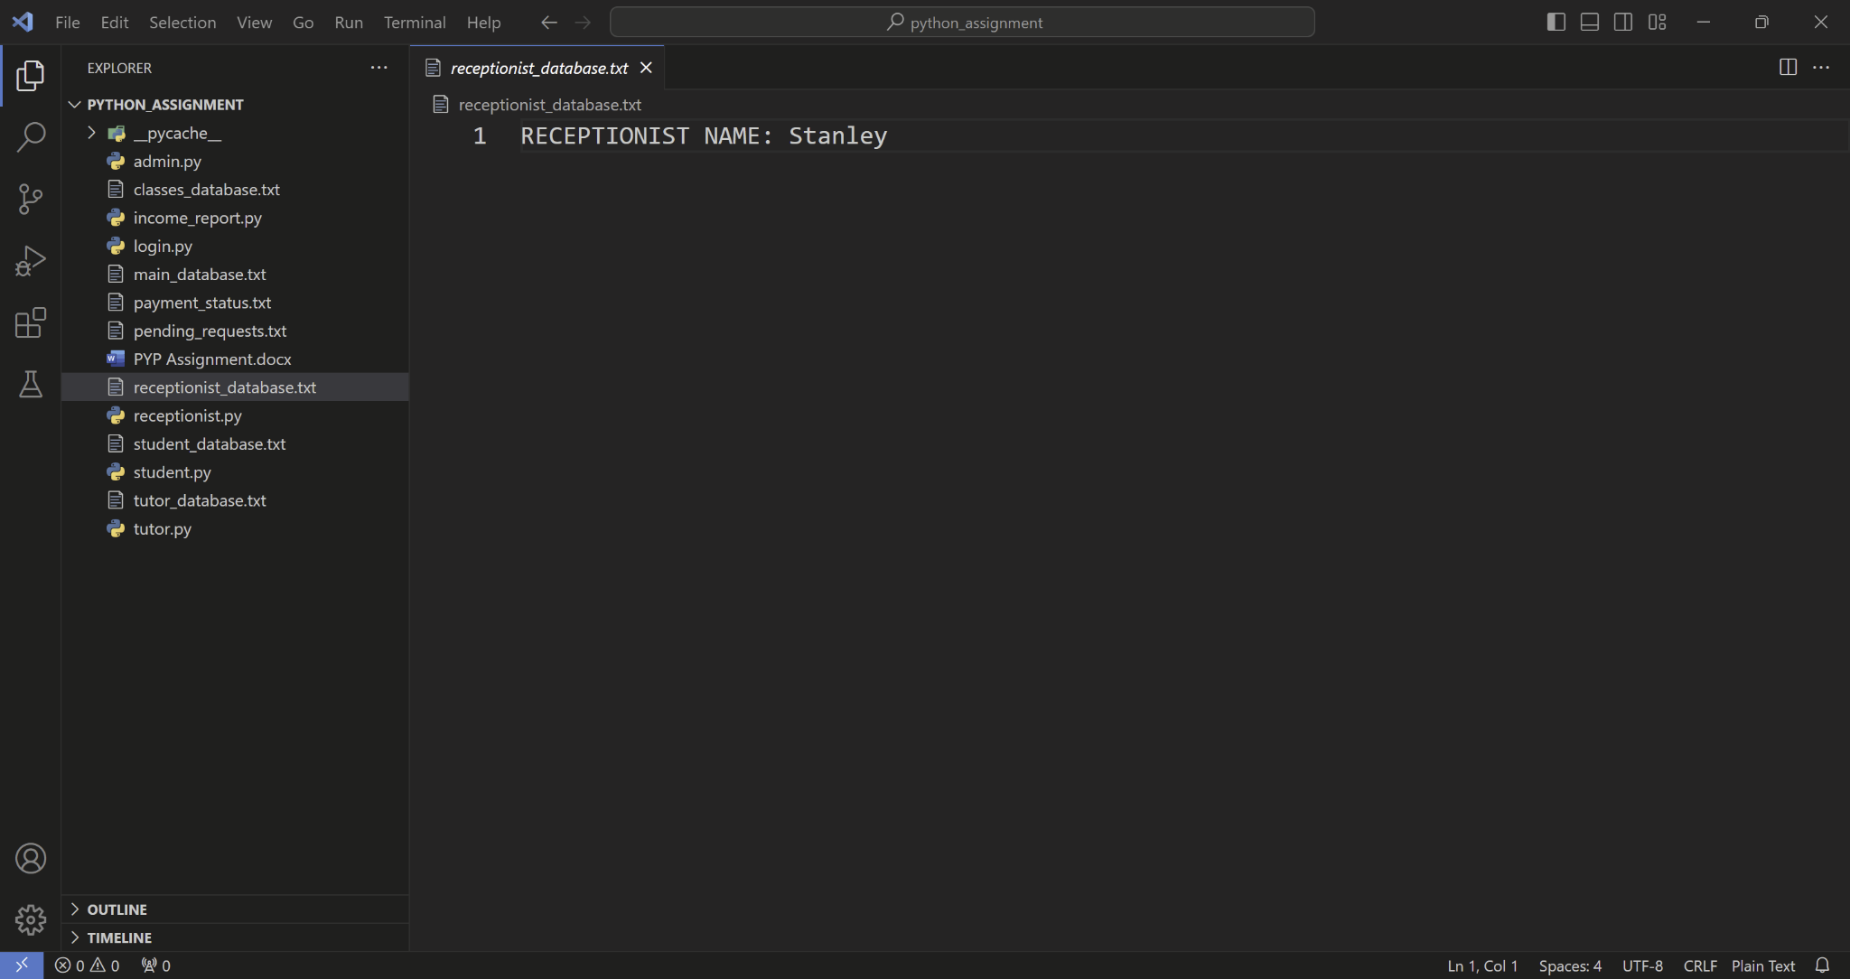

*FIGURE 7.2: receptionist_database.txt before registering a new receptionist*

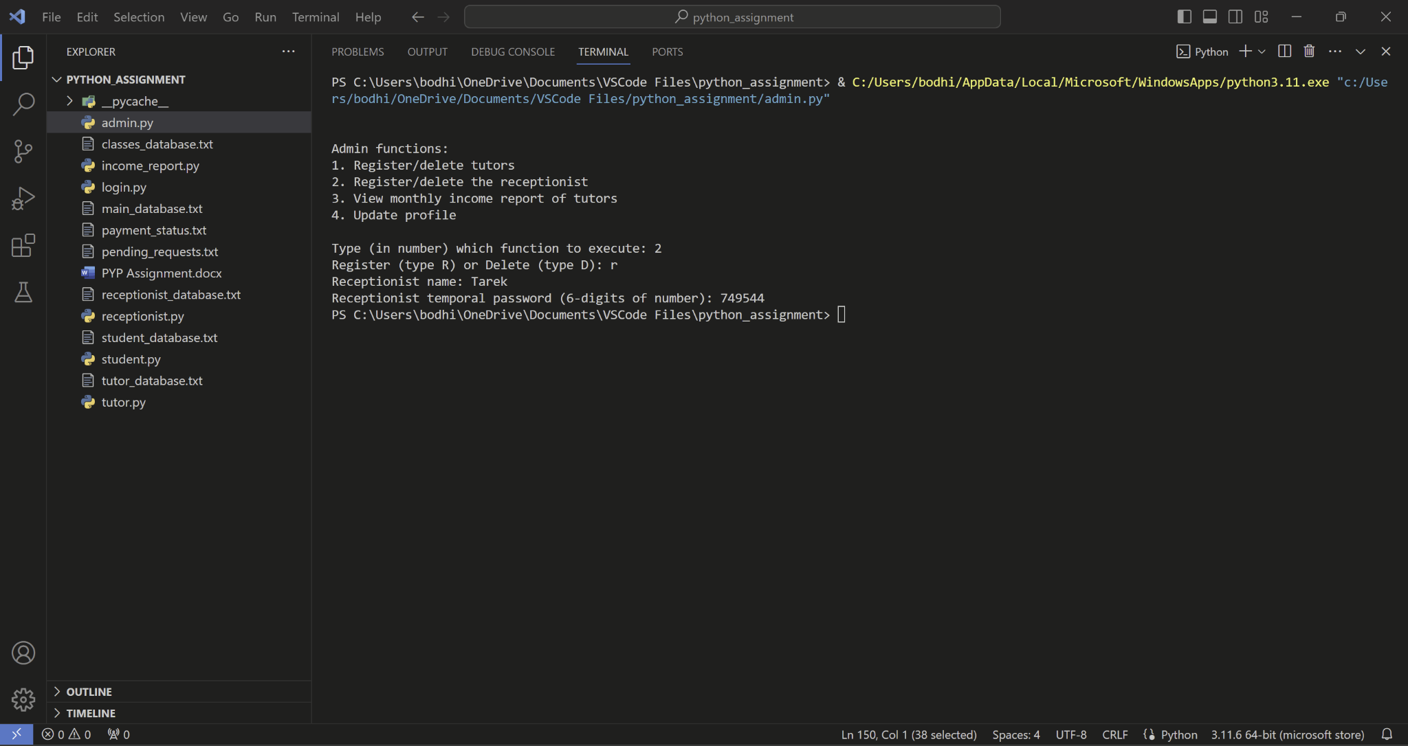

*FIGURE 7.3: run admin.py and use function 2, registering a new receptionist*

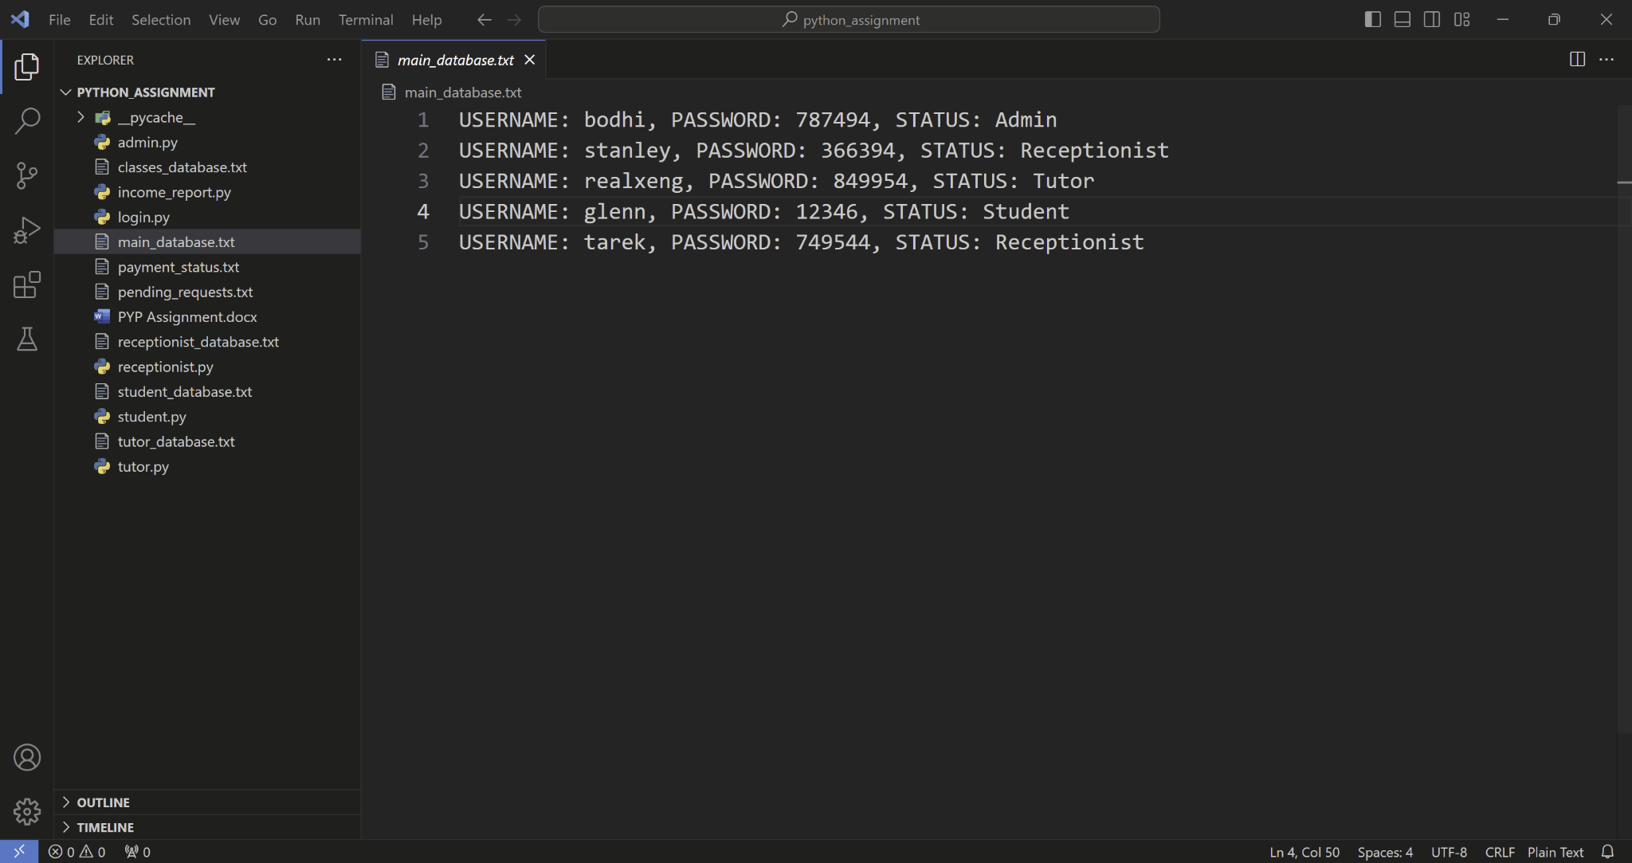

*FIGURE 7.4: main_database.txt after the new receptionist got registered*

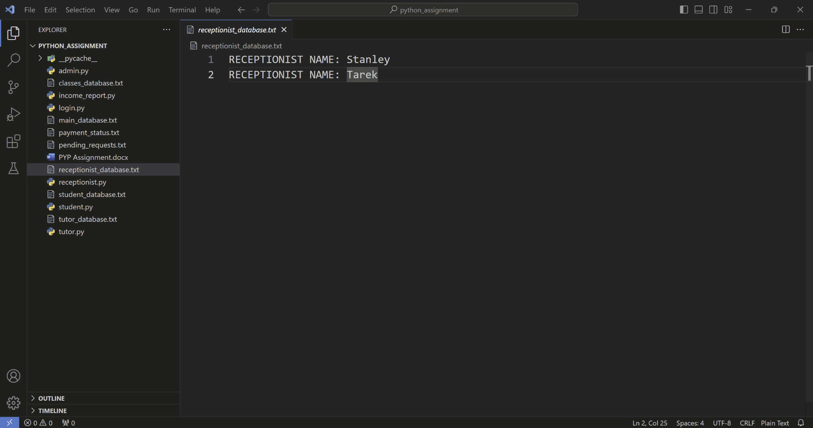

*FIGURE 7.5: receptionist_database.txt after the new receptionist got registered*

**Delete a receptionist**

**

*FIGURE 8.1: main_database.txt before a receptionist got deleted*

*FIGURE 8.2: receptionist_database.txt before a receptionist got deleted*

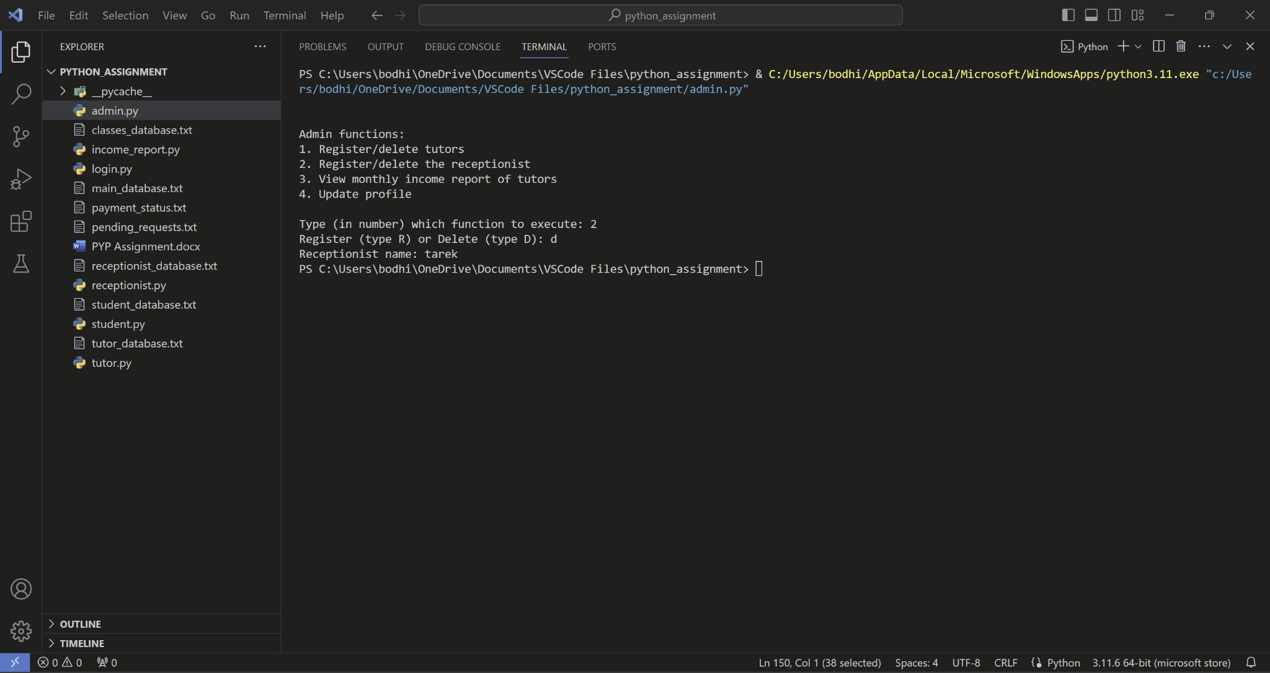

*FIGURE 8.3: run admin.py and use function 2, delete a receptionist*

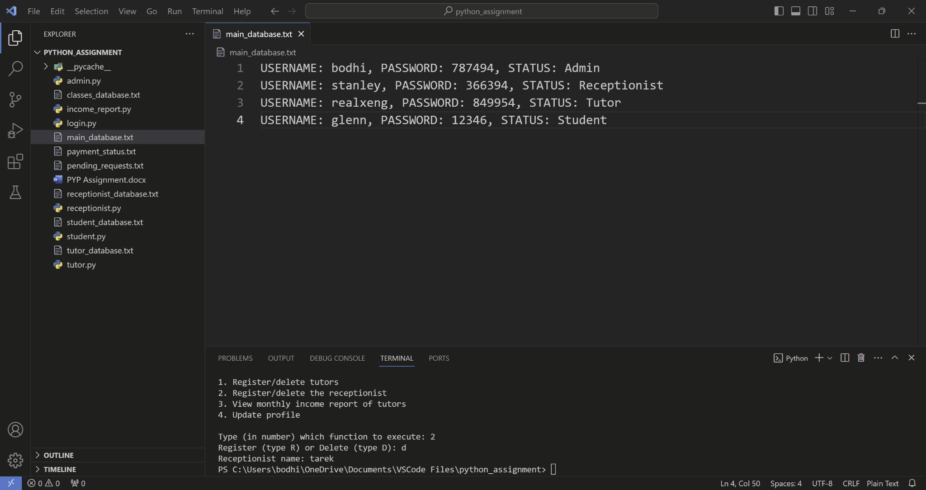

*FIGURE 8.4: main_database.txt after a receptionist got deleted*

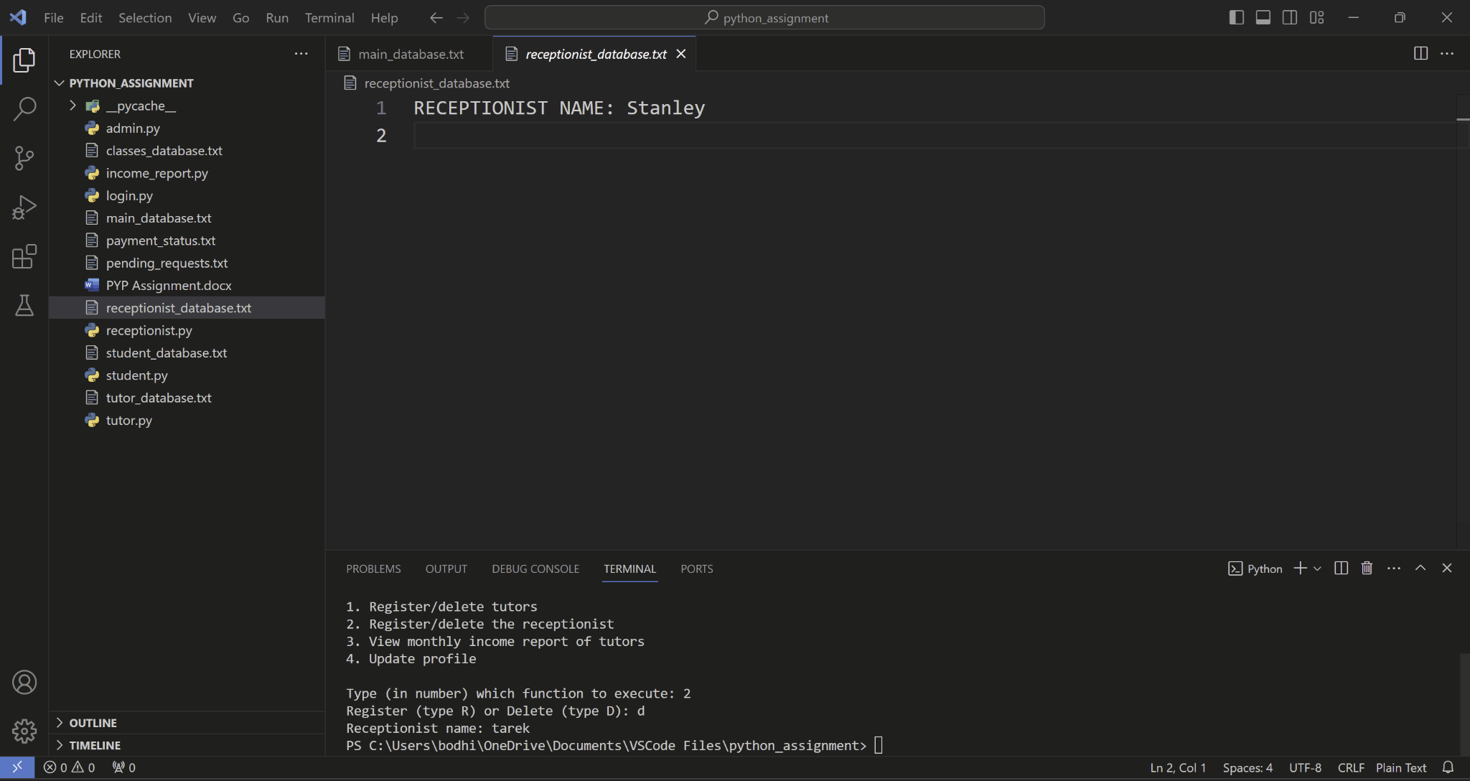

*FIGURE 8.5: receptionist_database.txt after a receptionist got deleted*

### Admin function 3: View the monthly income of a tutor

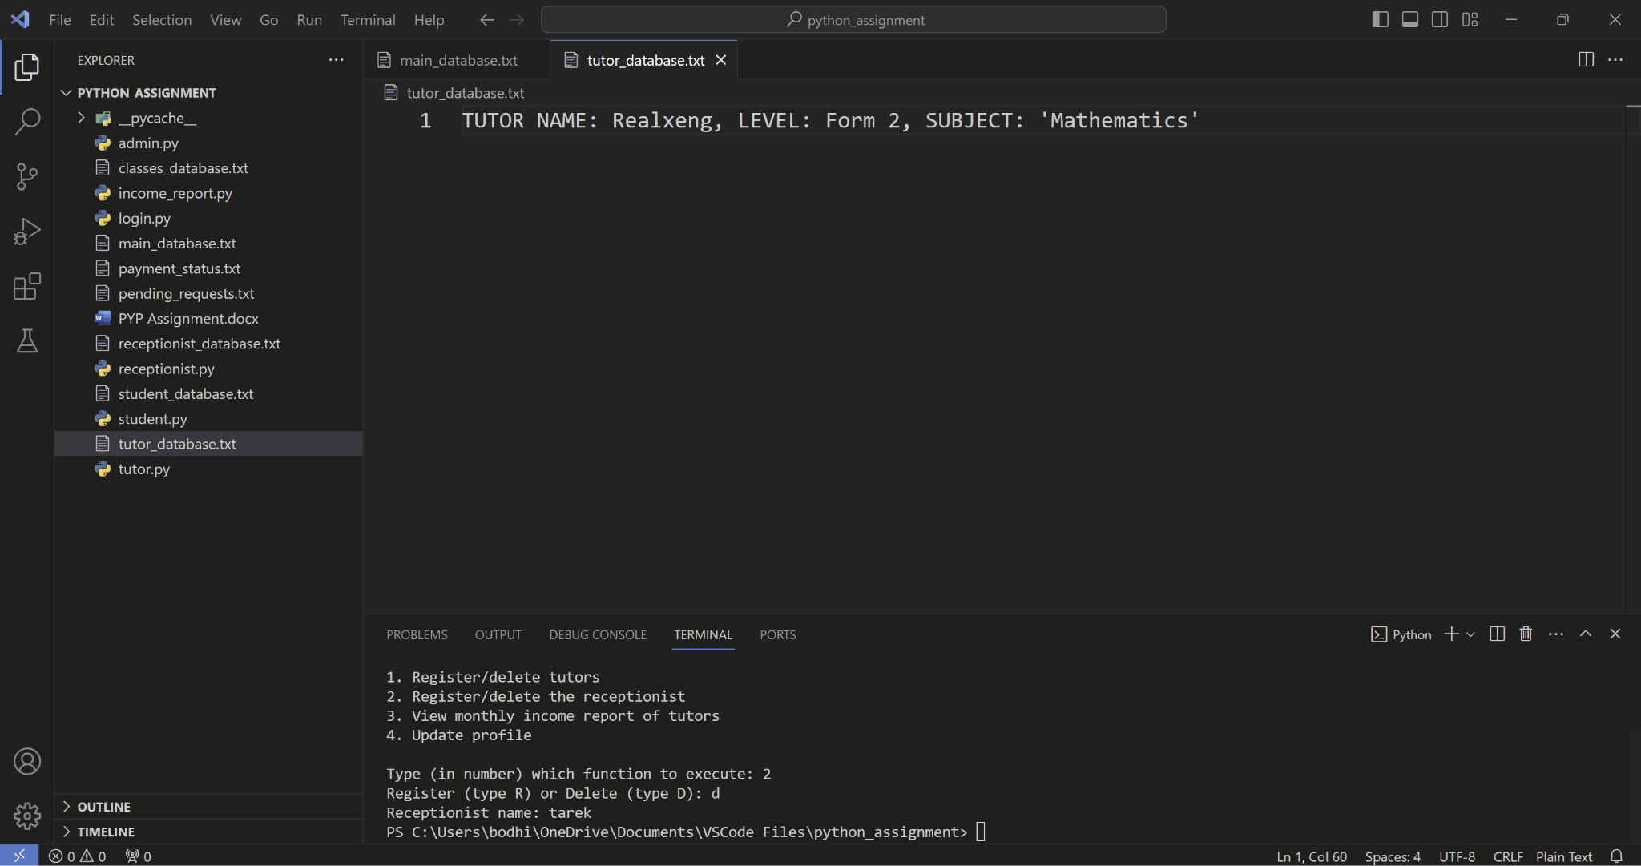

*FIGURE 9.1: current data in tutor_database.txt, will be useful for the input process*

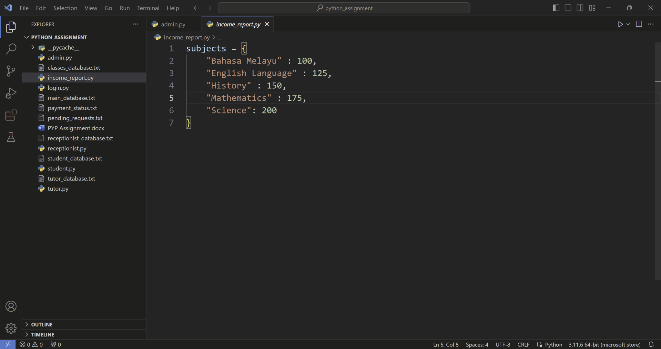

*FIGURE 9.2: current data in income_report.py, will be imported to admin.py for use*

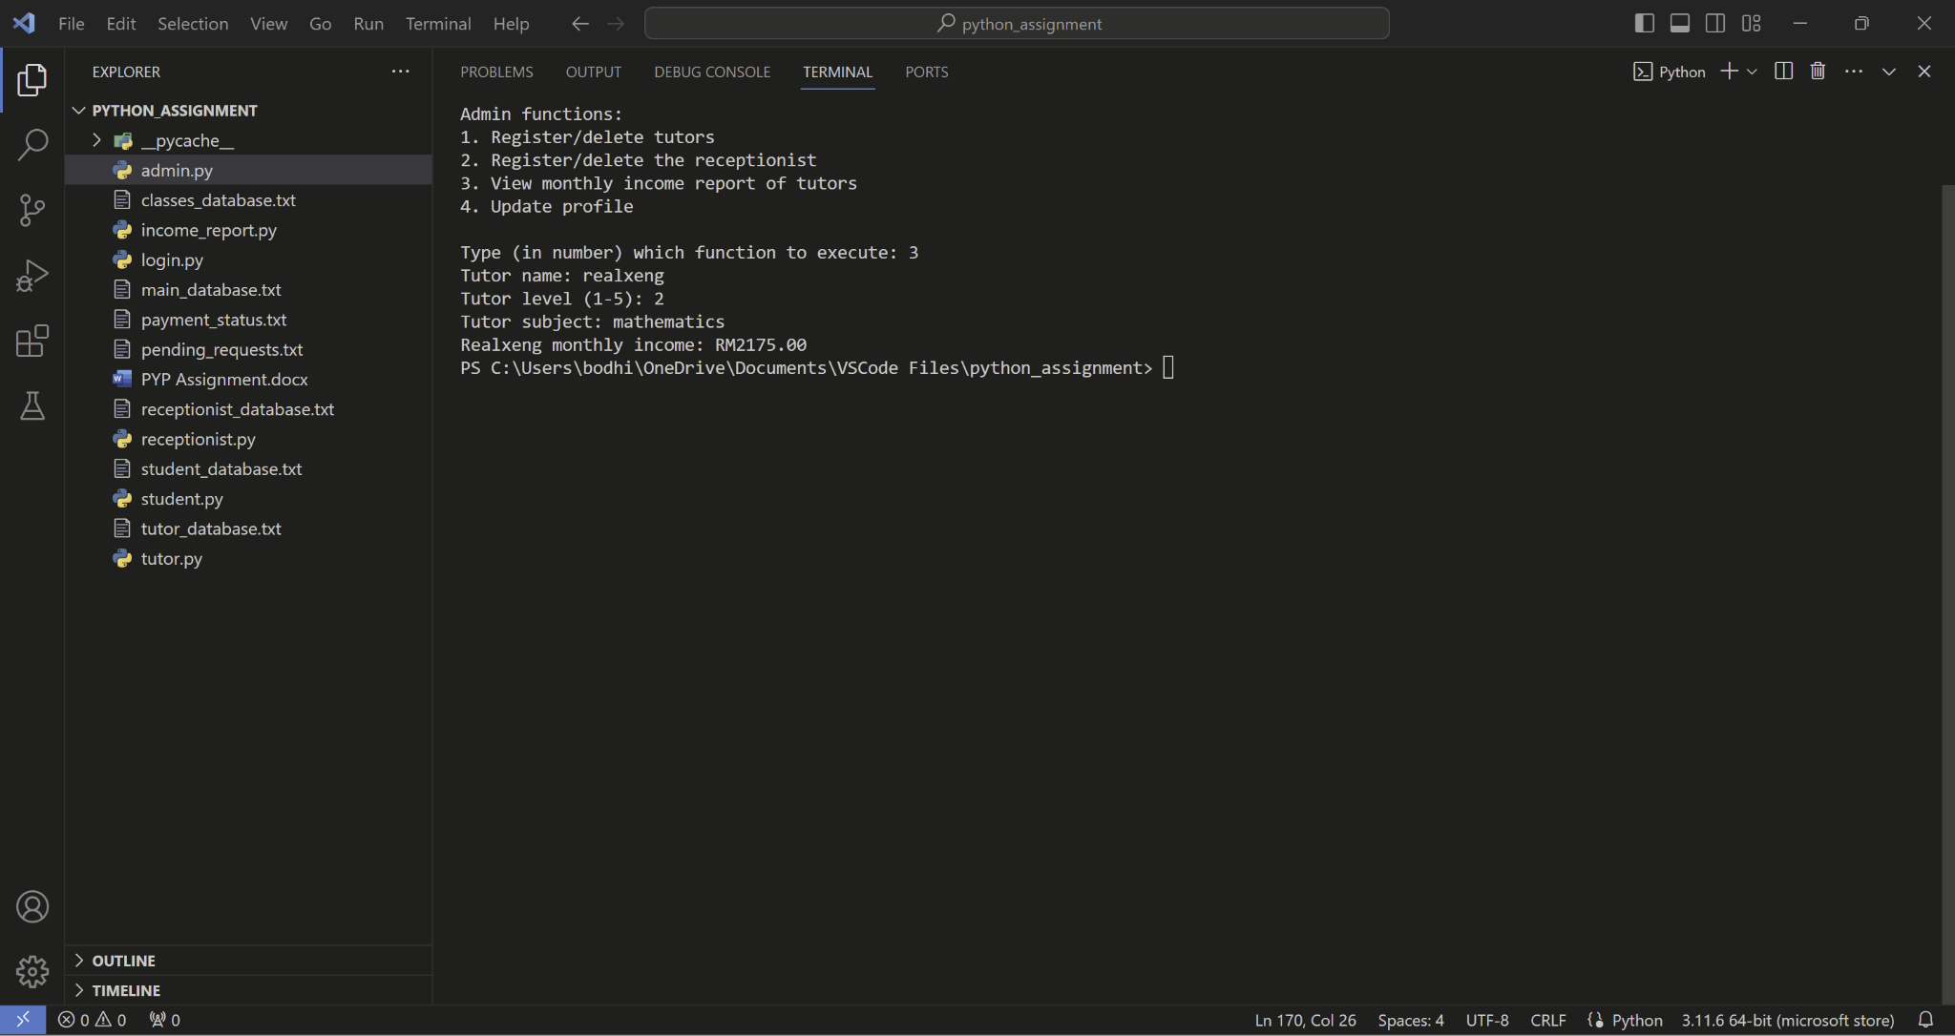

*FIGURE 9.3: run admin.py and use function 3, input will be entered and have its output shown in the terminal*

### Admin function 4: Update admin’s own profile

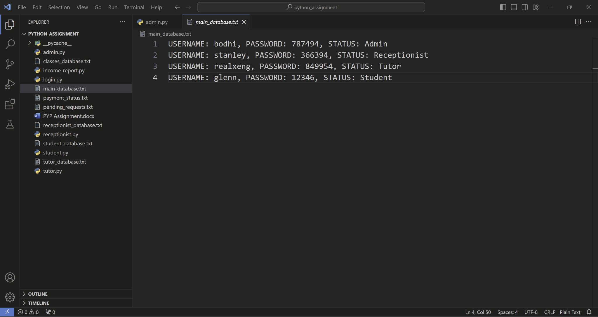

*FIGURE 10.1: main_database.txt before admin’s profile is updated*

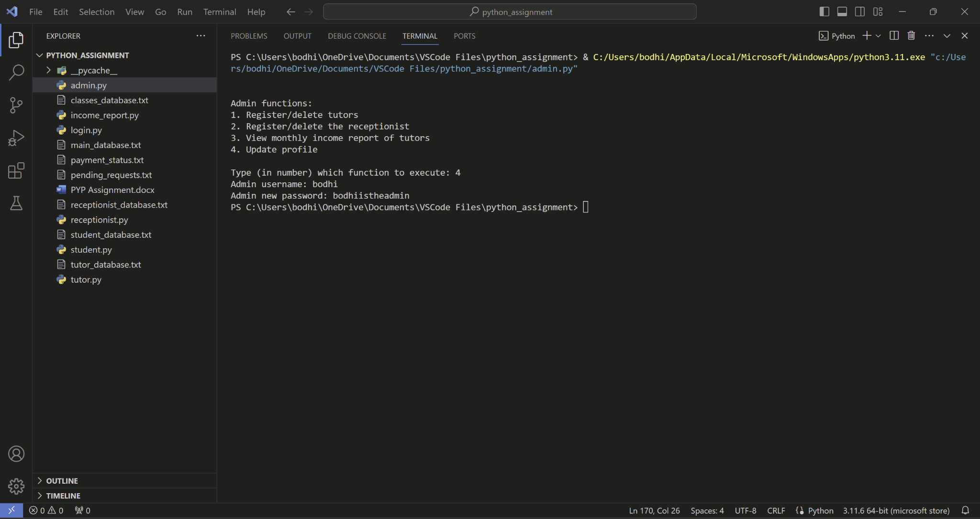

*FIGURE 10.2: run admin.py and use function 4, update admin’s own profile*

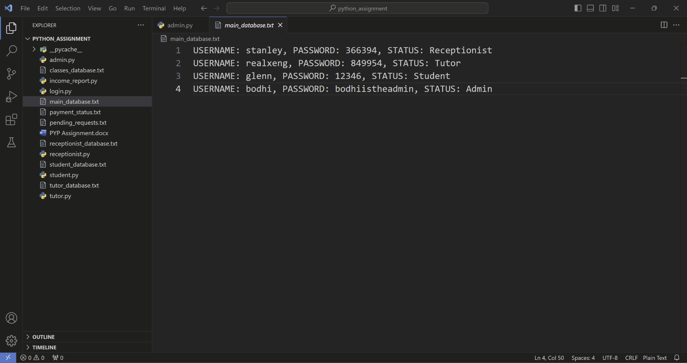

*FIGURE 10.3: main_database.txt after admin’s own profile is updated*

## Tutor

### Tutor Function 1: Add Class Information

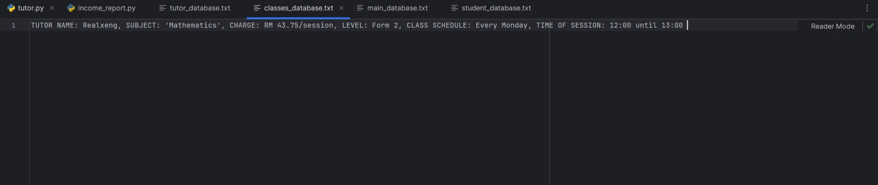

*Figure 16.1: classes_database.txt before adding class information*

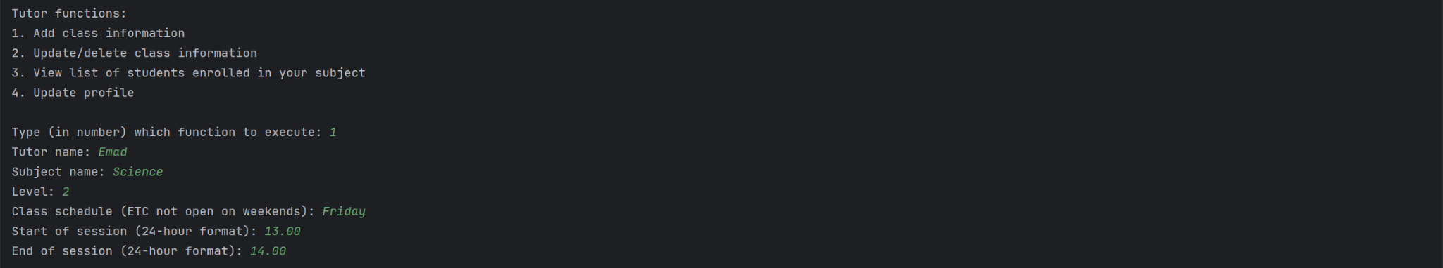

*Figure 16.2: input for tutor.py first function add class information*

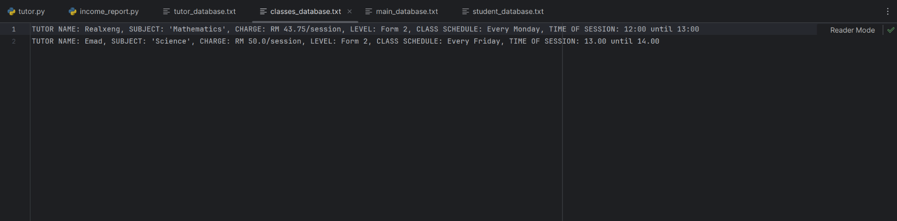

*Figure 16.3: classes_database.txt after adding class information*

### Tutor Function 2: Update/Delete Class Information

**Update Class Information**

**

*Figure 17.1: classes_database.txt before updating class information*

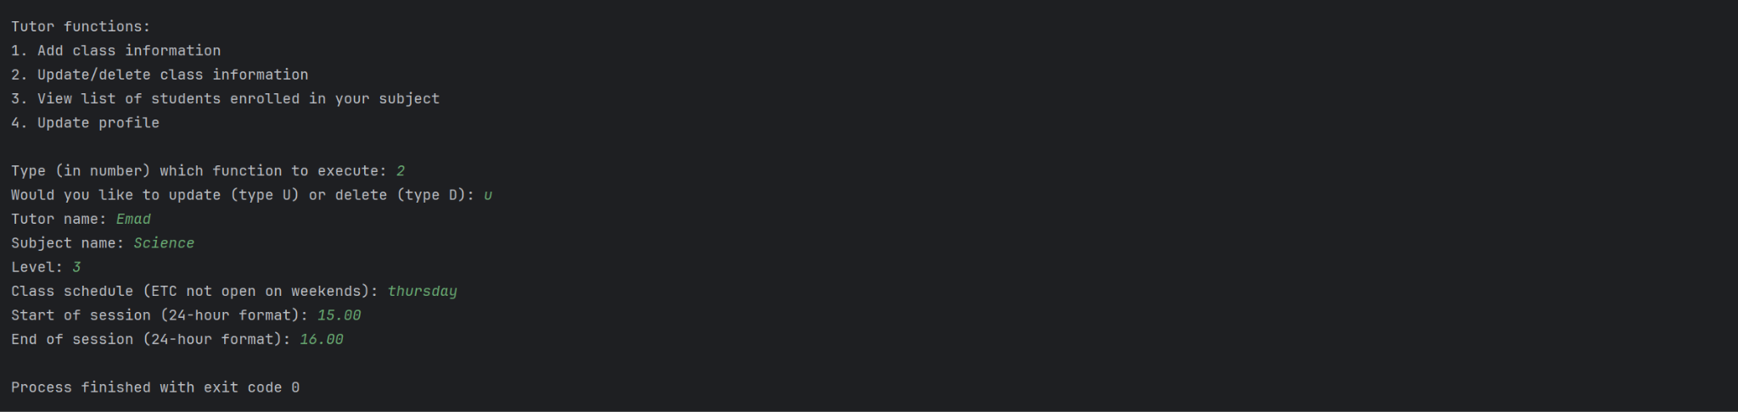

*Figure 17.2: input for tutor.py second function update class information*

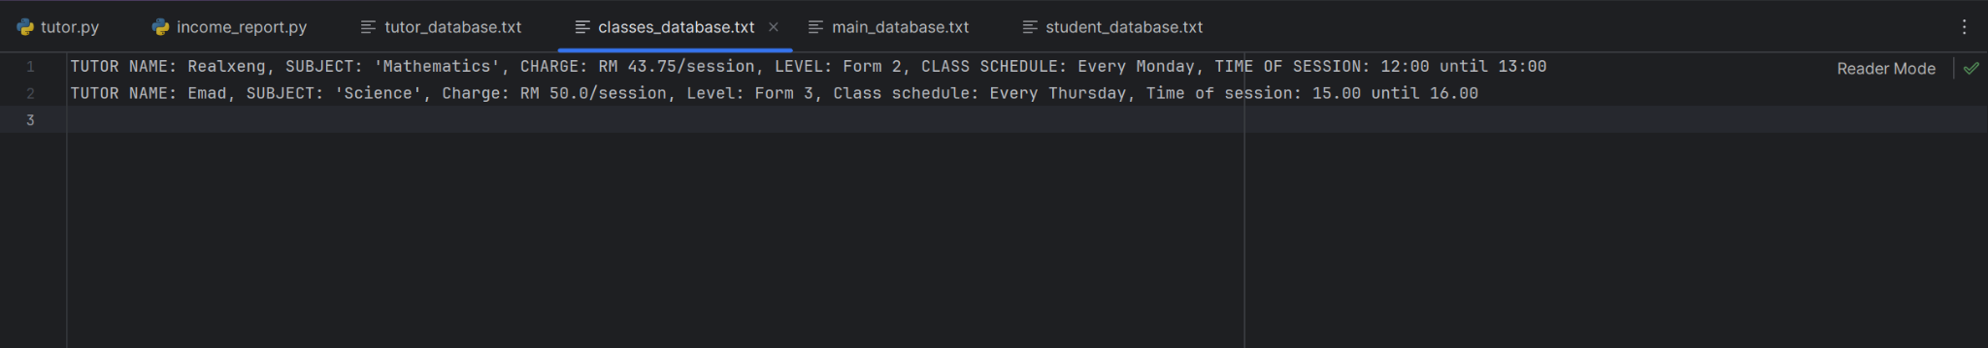

*Figure 17.3: classes_database.txt after updating class information*

**Delete Class Information**

**

*Figure 18.1: classes_database.txt before deleting class information*

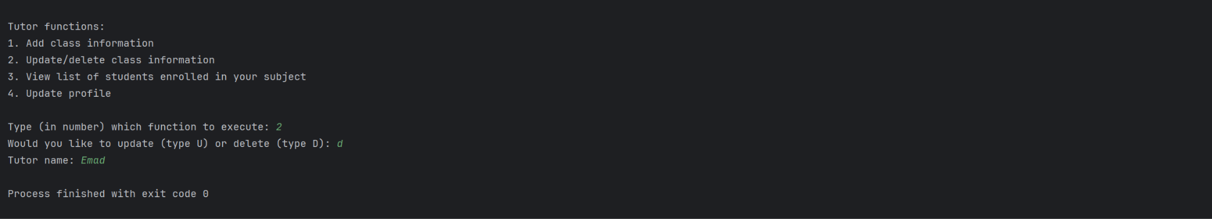

*Figure 18.2: input for tutor.py second function delete class information*

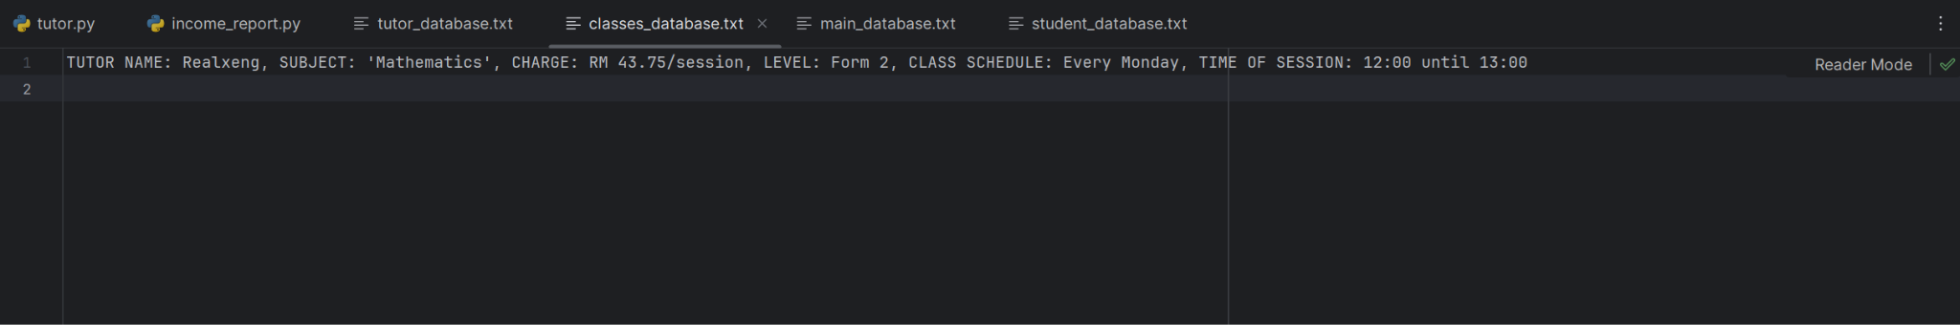

*Figure 18.3: classes_database.txt after deleting class information*

### Tutor Function 3: View List of Student Enrolled in Your Subject

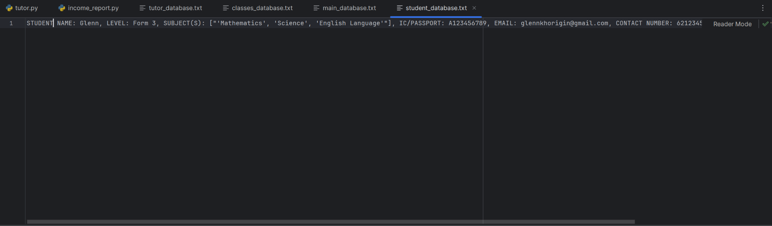

*Figure 19.1: student_database.txt*

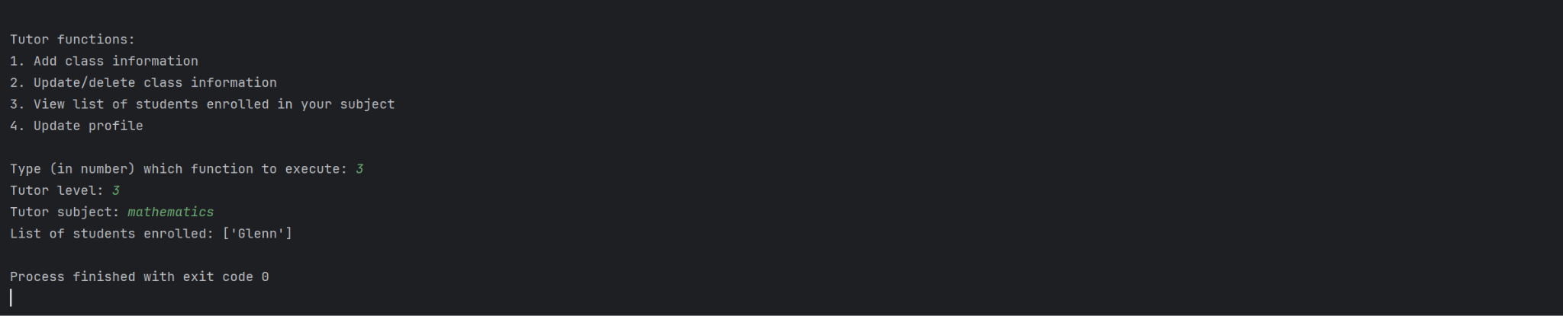

*Figure 19.2: input and output for tutor.py third function view list of student enrolled in tutor’s subject*

### Tutor Function 4: Update Profile

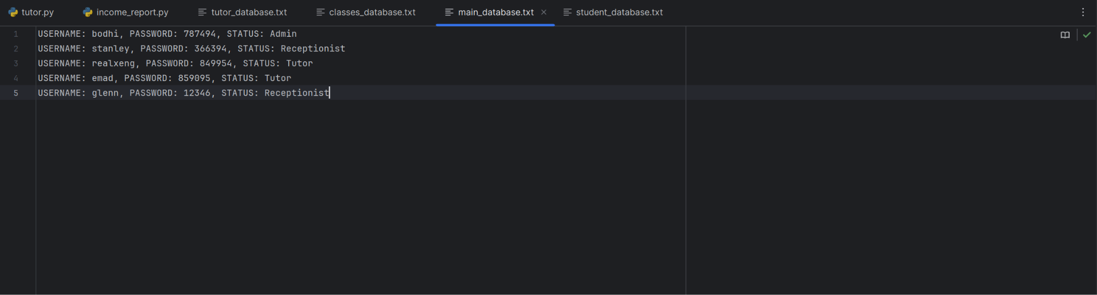

*Figure 20.1: main_database.txt before profile update*

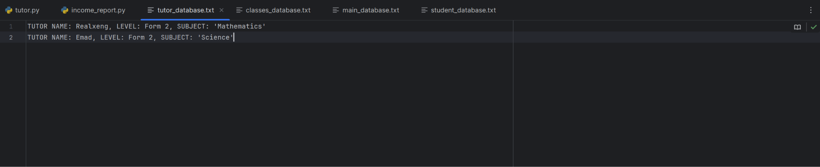

*Figure 20.2: tutor_database.txt before profile update*

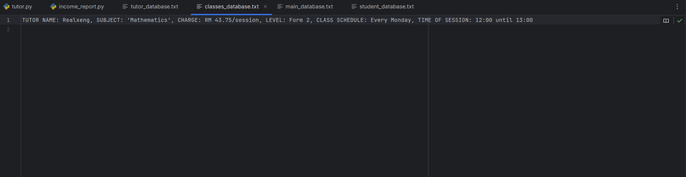

*Figure 20.3: classes_database.txt before profile update*

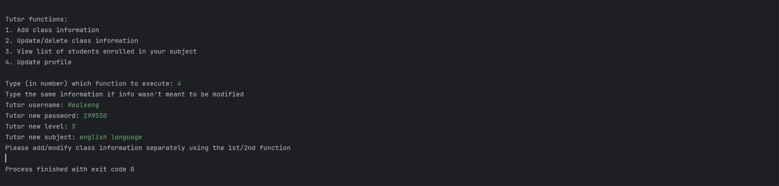

*Figure 20.4: input for tutor.py fourth function update profile*

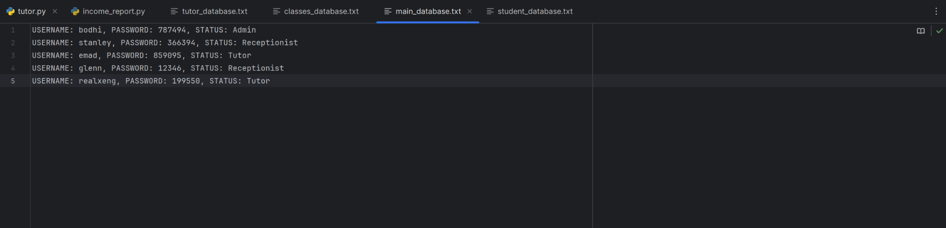

*Figure 20.5: main_database.txt after profile update*

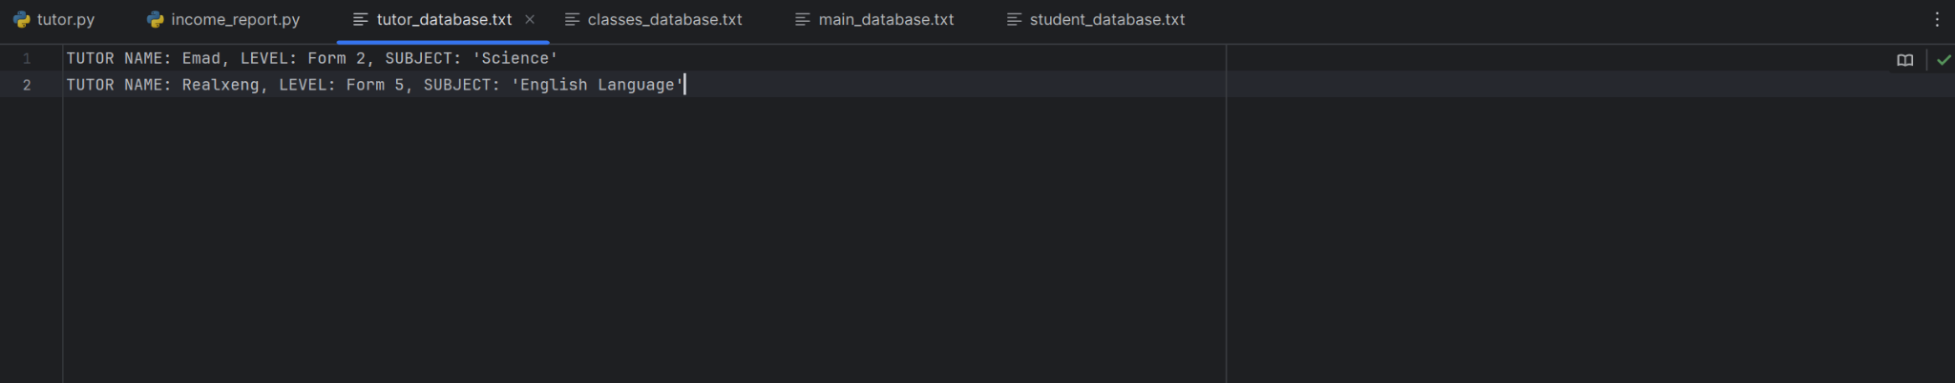

*Figure 20.6: tutor_database.txt after profile update*

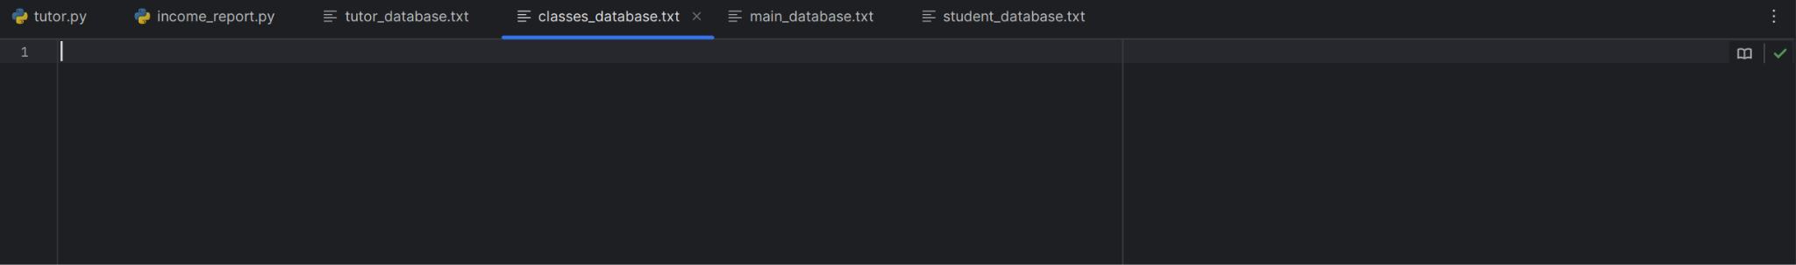

*Figure 20.7: classes_database.txt after profile update*

## Receptionist

### Receptionist Function 1: Register a student



*Figure 21.1: student_database.txt before registering student*

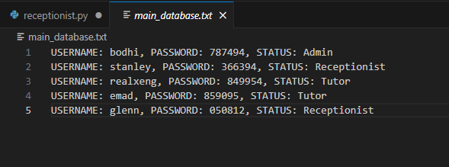

*Figure 21.2: main_database.txt before registering student*

## 

*Figure 21.3: Run receptionist.py and use function 1, starting student registration process*

**

*Figure 21.4: student_database.txt after registering student*

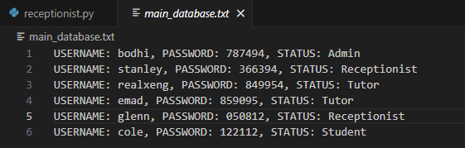

*Figure 21.5: main_database.txt after registering student*

### Receptionist Function 2: Update subject enrollment

**

*Figure 22.1: student_database.txt before updating subject enrollment*

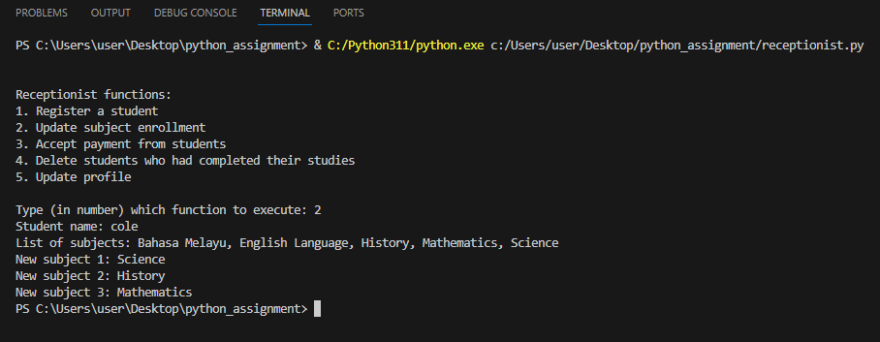

*Figure 22.2: Run receptionist.py and use function 2, updating student’s subject enrollment*

**

*Figure 22.3: student_database.txt after updating student’s subject enrollment*

### Receptionist Function 3: Accept payment from students

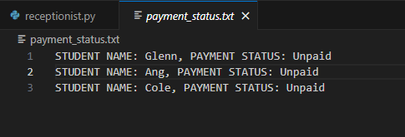

*Figure 23.1: payment_status before accepting payment from student*

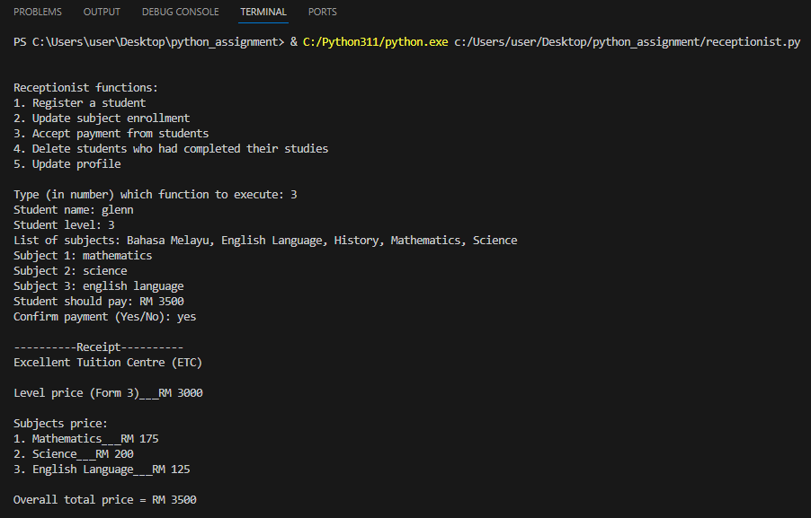

*Figure 23.2: Run receptionist.py and use function 3, updating student payment status*

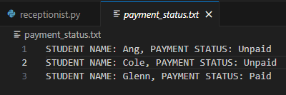

*Figure 23.3: payment_status.txt after confirming student payment status*

### Receptionist Function 4: Delete students who had completed their studies.

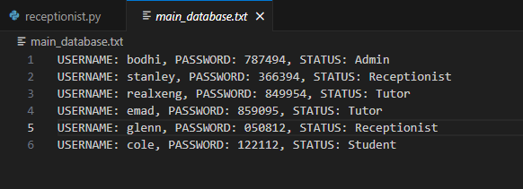

*Figure 24.1: main_database.txt before execution of function 4*

**

*Figure 24.2: student_database.txt before execution of function 4*

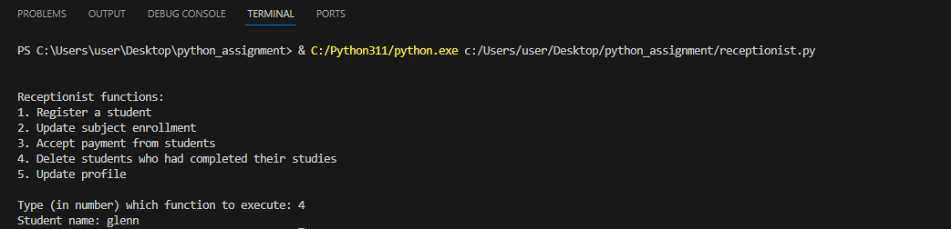

*Figure 24.3: Run receptionist.py and use function 4, erasing student profile*

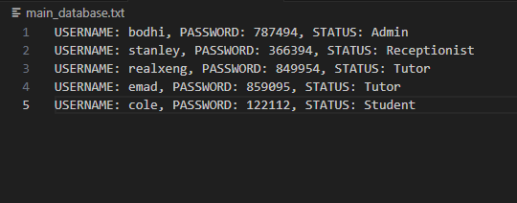

*Figure 24.4: main_database.txt after erasing student profile*

**

*Figure 24.5: student_database.txt after erasing student profile*

### Receptionist Function 5: Update profile

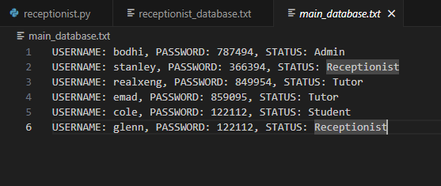

*Figure 25.1: main_database.txt before updating receptionist database*

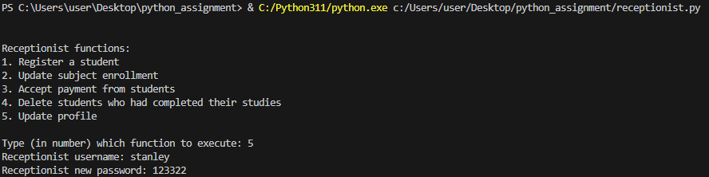

*Figure 25.2: Run receptionist.py and run function 5*

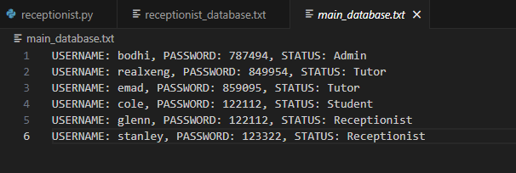

*Figure 25.3: main_database.txt after updated profile*

## Student

### Student Function 1: View class schedule

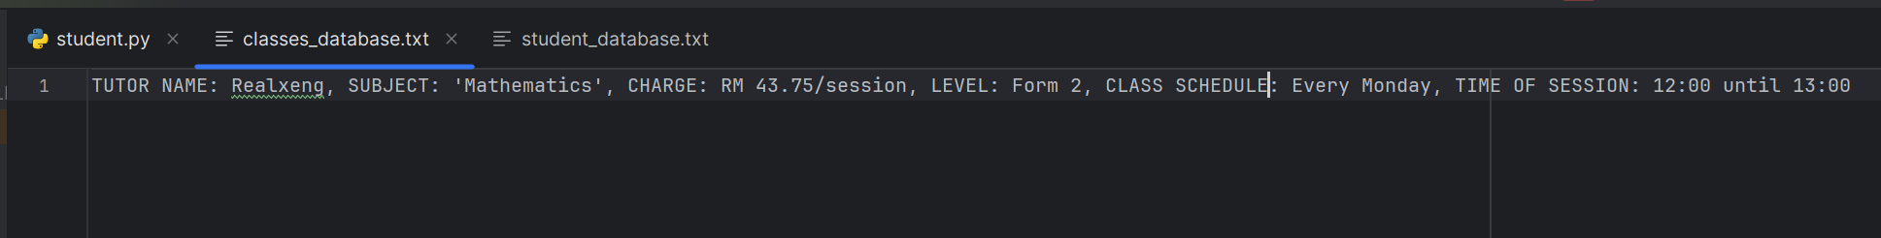

*Figure 26.1: classes_database.txt*

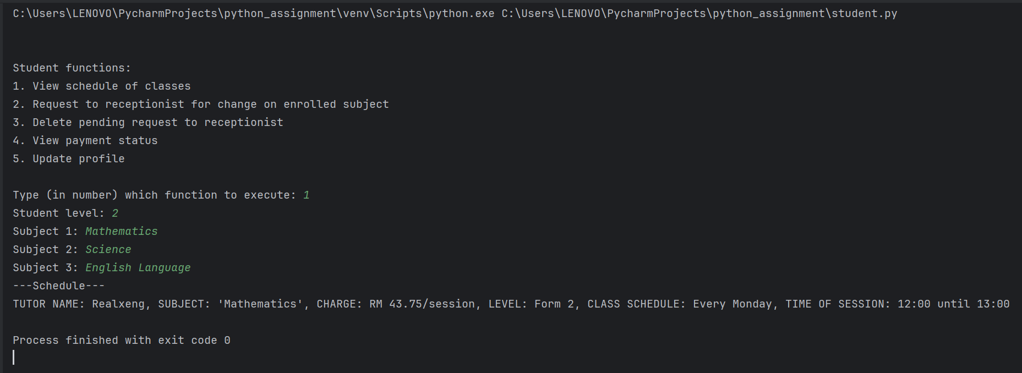

*Figure 26.2: Student input for viewing schedule*

### Student Function 2: Request subject change

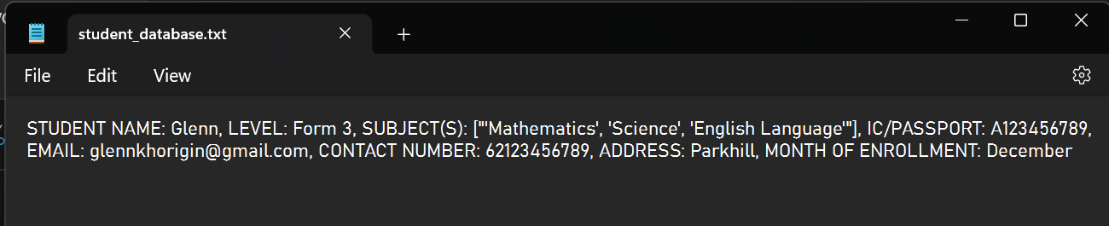

*Figure 27.1: student_database.txt for student name verification*

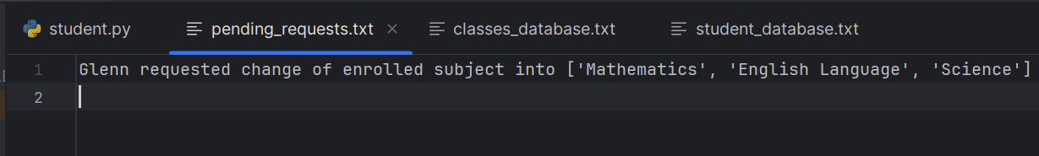

*Figure 27.2: pending_requests.txt before subject change request*

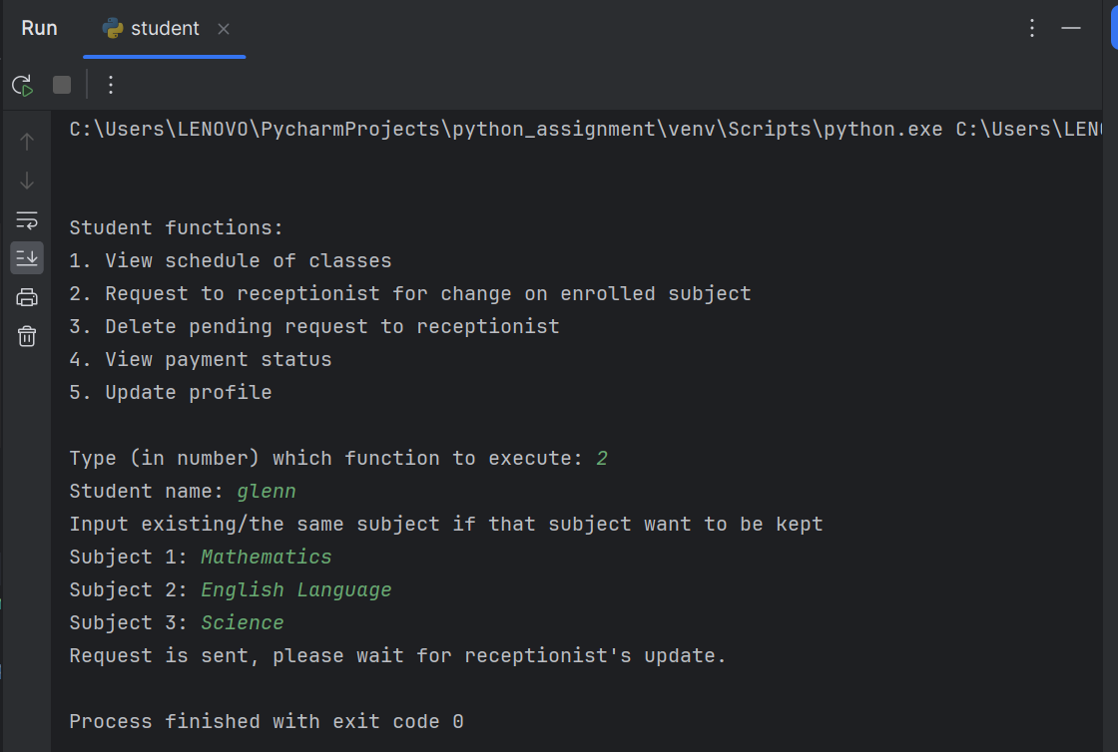

*Figure 27.3: Student input to request subject change*

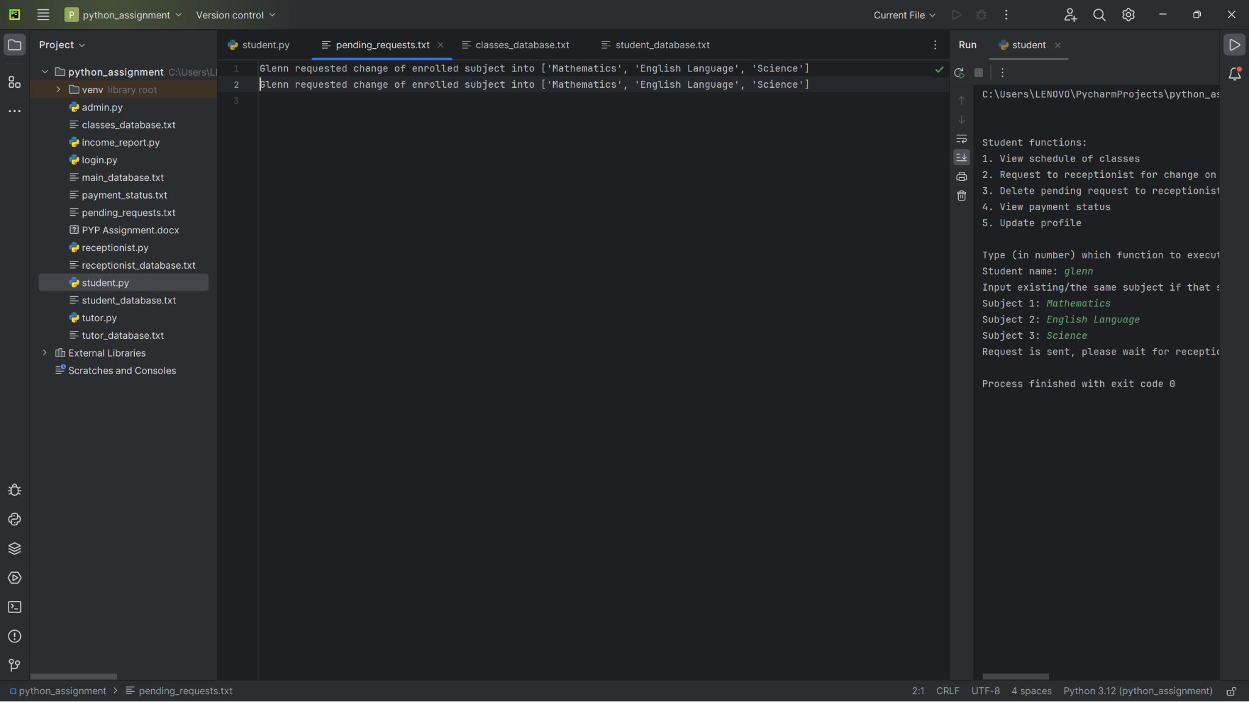

*Figure 27.4: pending_requests.txt after student request*

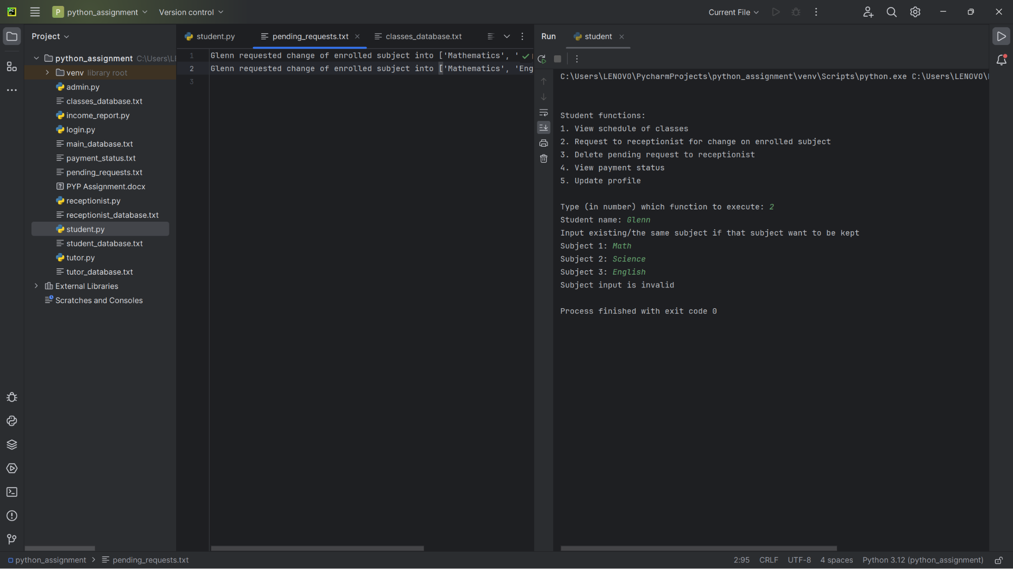

*Figure 27.5: Invalid subject input done by student*

### Student Function 3: Remove subject change request

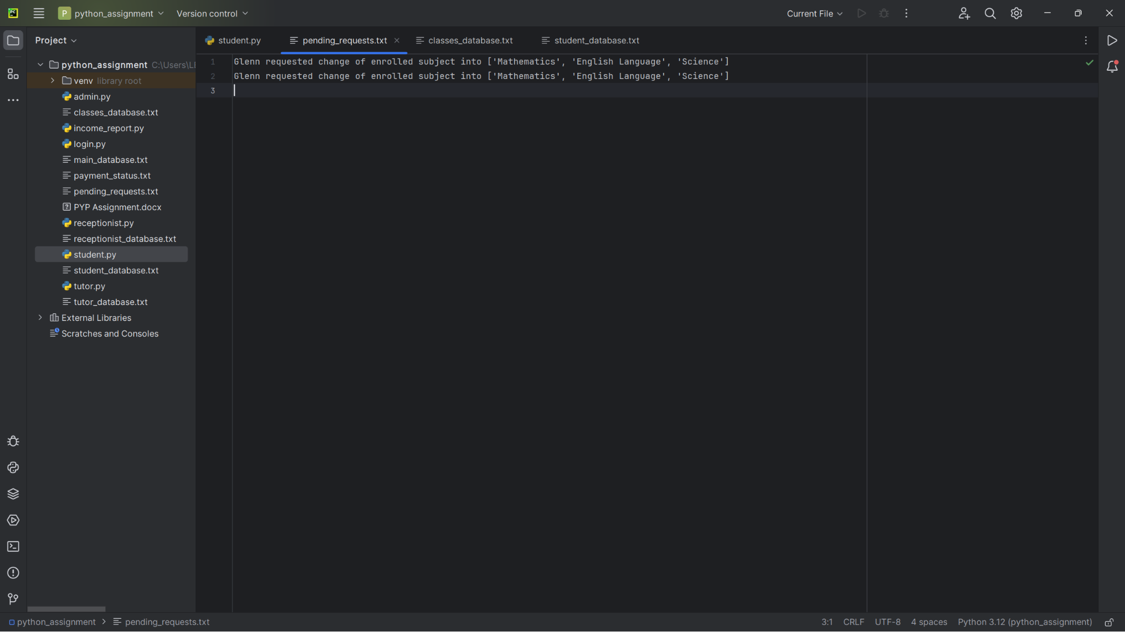

*Figure 28.1: pending_requests.txt before request removal*

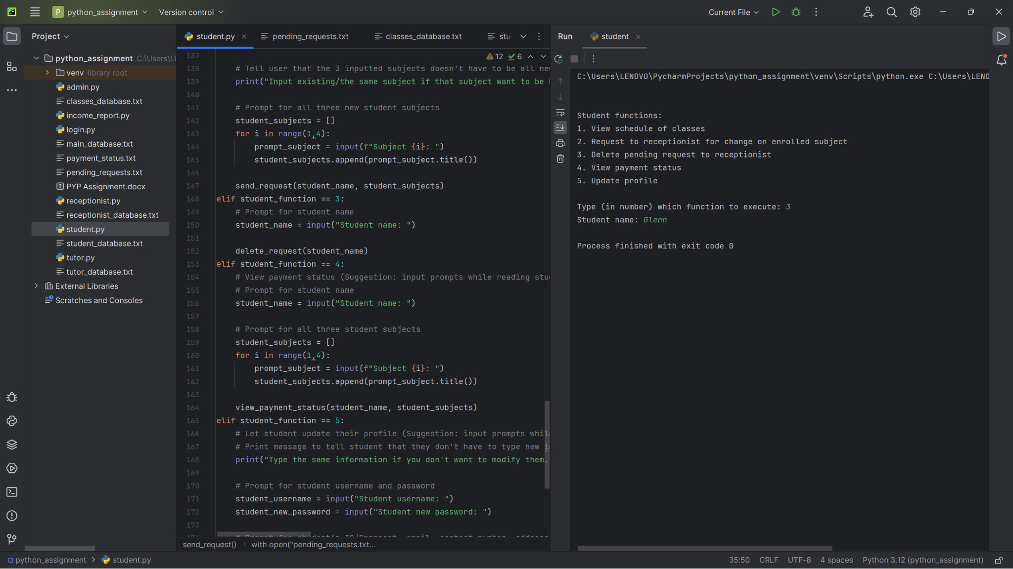

*Figure 28.2: Student input to delete request*

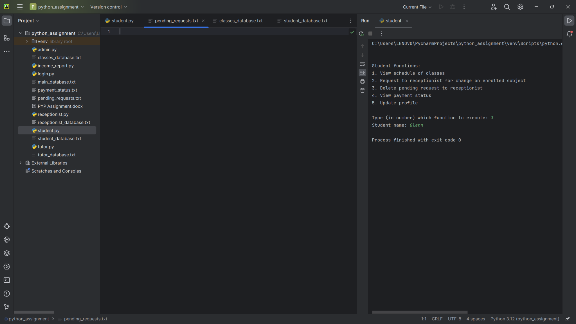

*Figure 28.3: pending_requests.txt after request deletion*

### Student Function 4: View payment status

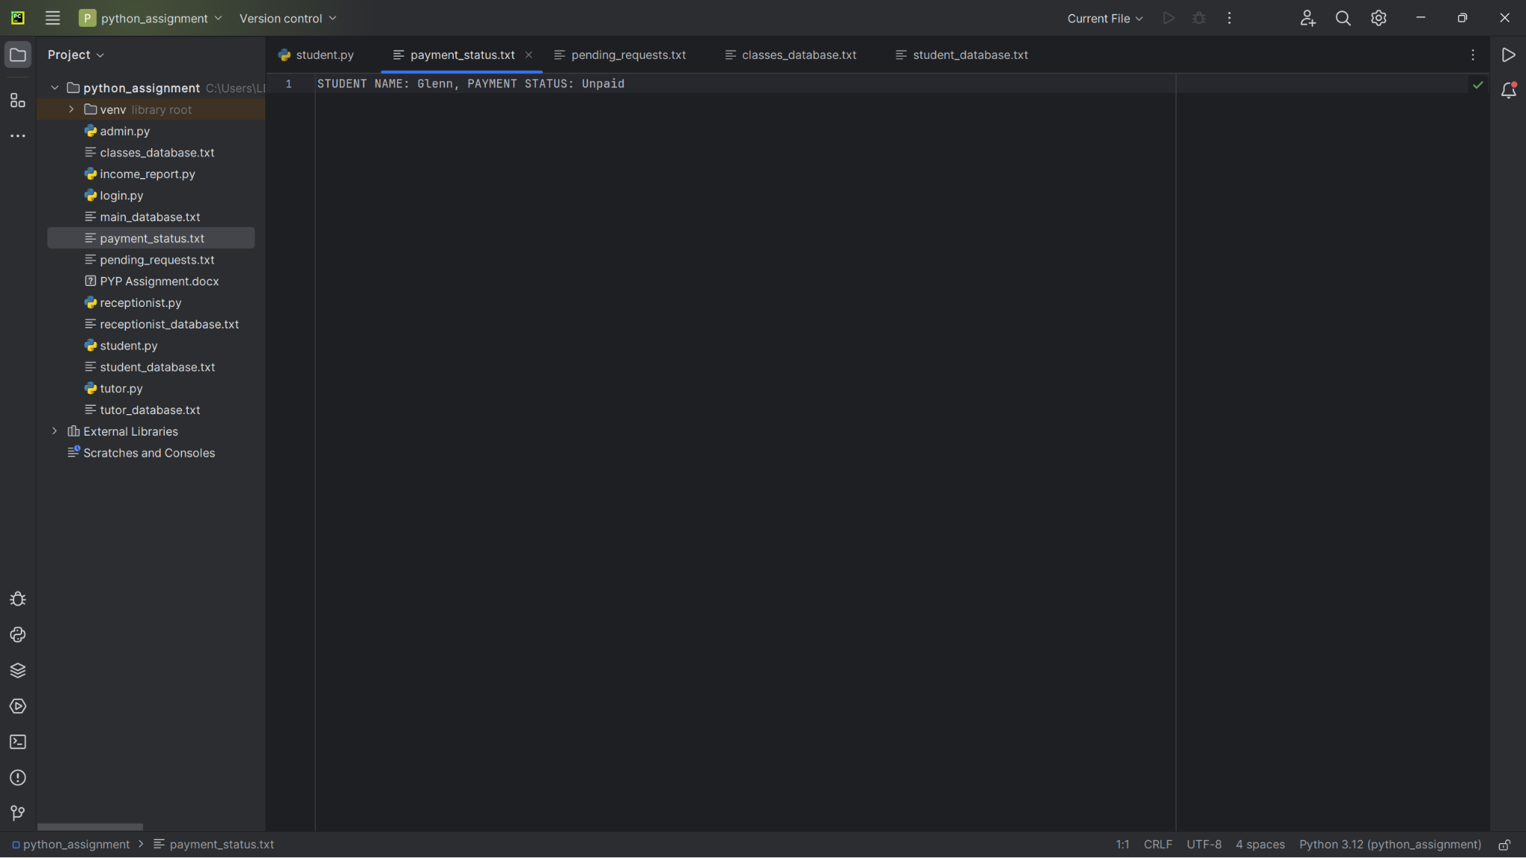

*Figure 29.1: payment_status.txt for reading data*

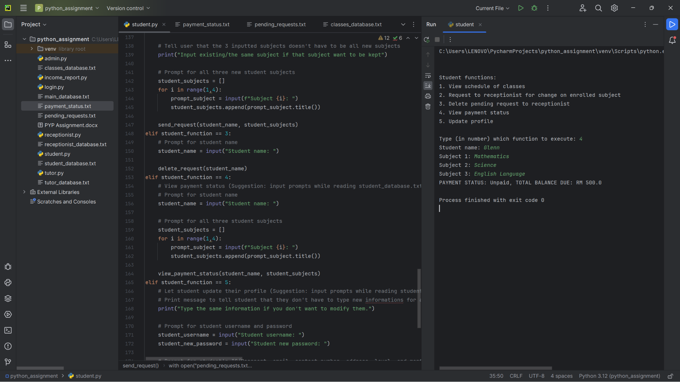

*Figure 29.2: Student viewing payment status*

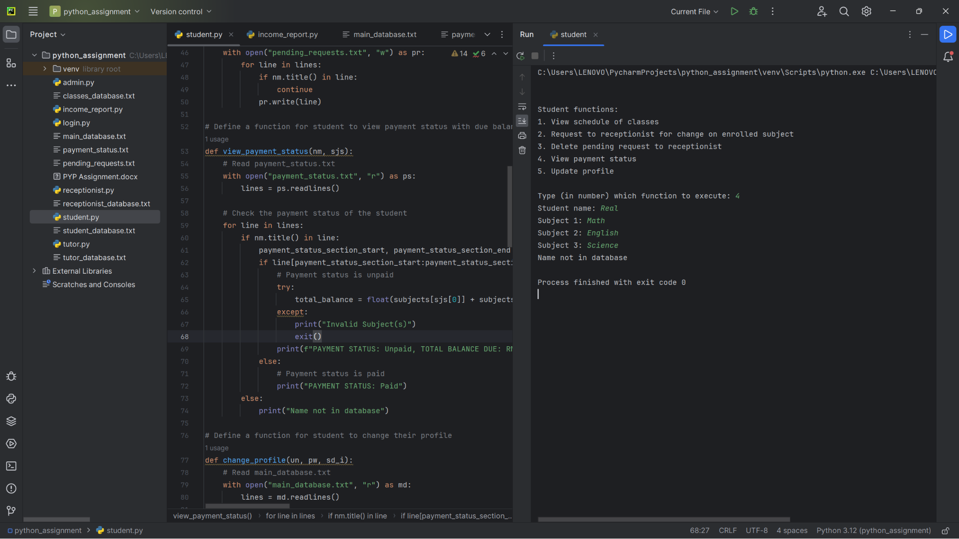

*Figure 29.3: Student entering invalid name*

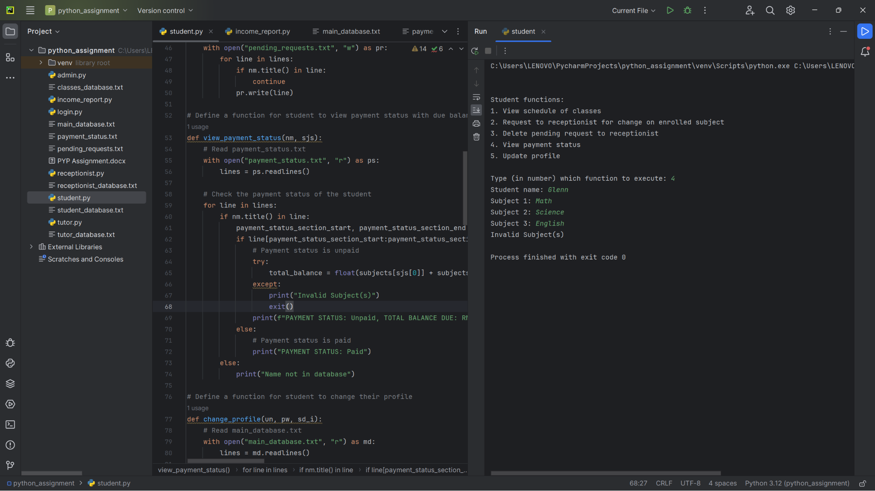

*Figure 29.4: Student entering subject that is not in database*

### Student Function 5: Update student data

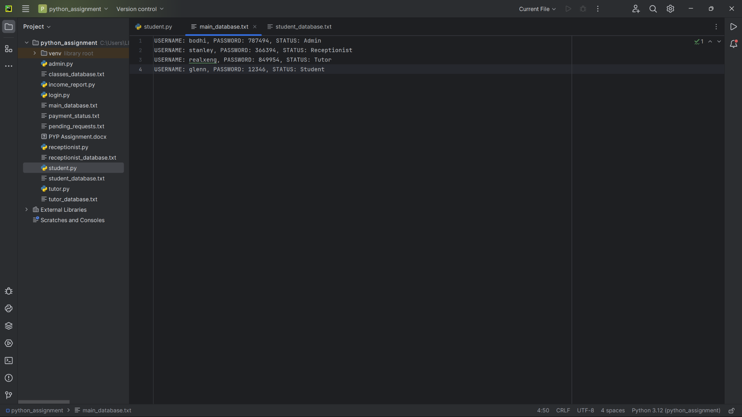

*Figure 30.1: main_database.txt before data update*

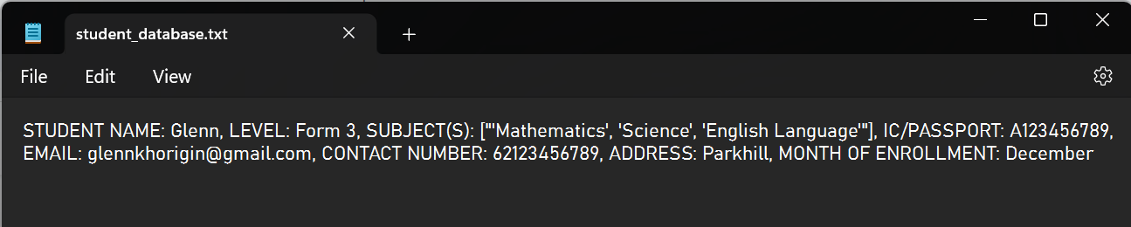

*Figure 30.2: student_database.txt before data update*

*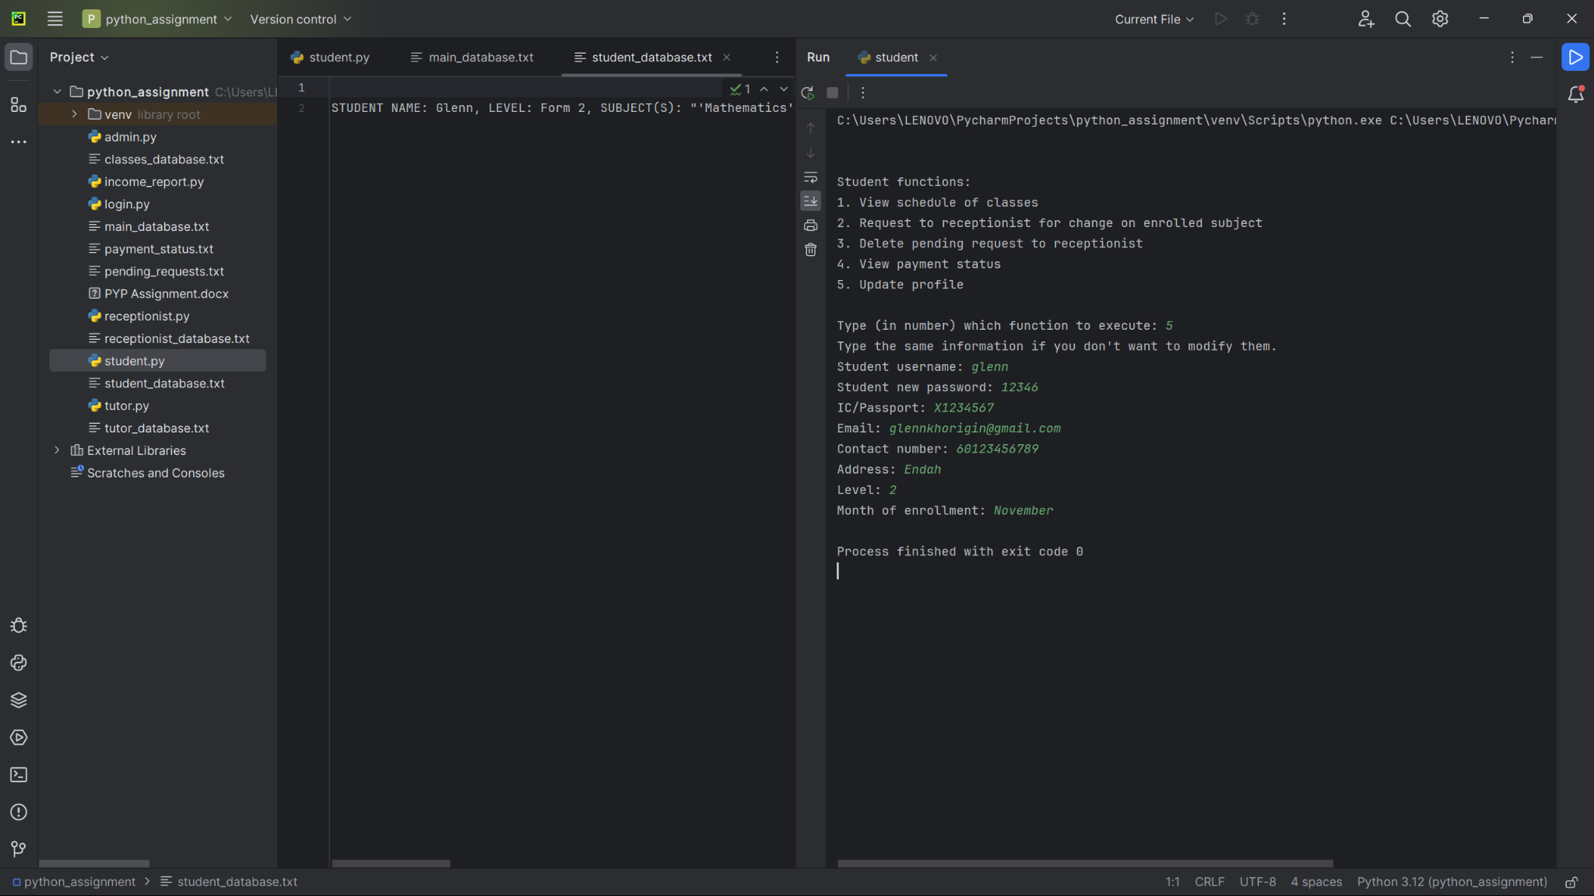Figure 30.3: Student input for profile data update*

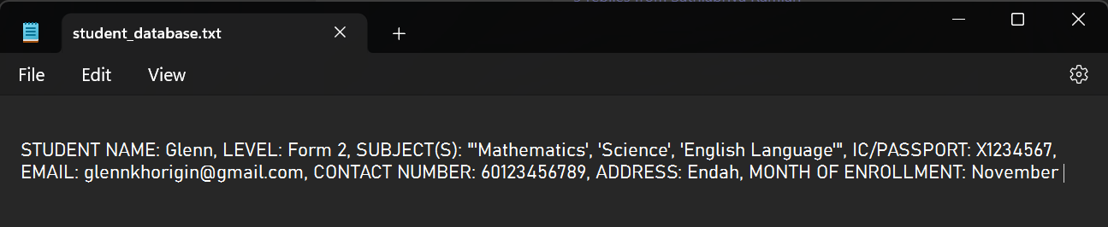

*Figure 30.4: student_database.txt after data update*

# 

# Conclusion

With the help of this program, Excellent Tuition Center would be able to digitize its database and speed up its data management. By having a program to manage all the administration and registration, it would be easier for both the students and tutors to monitor their fees and courses. It also helps centralize the management system. With the addition of this program, ETC would handle more students with ease and thus be able to offer their courses to more students.

As per the request of ETC, The program consists of 4 layers of administration. Starting with Admin and going down to tutor, receptionist, then the students. Admin has control of registering and deleting the tutors, registering and deleting the receptionists, viewing the monthly income of the tutors, and being able to update their profile. The tutor will be able to add the class information, update or delete the class information, view the list of students that are enrolled in their subject, and the tutor also can update their profile. The receptionist can register a student, update subject enrollment, accept payment from students, delete a student who finished their studies and update their profile. Lastly, the student would be able to view their course schedule, change their subject of interest, view their payment status, and update their profile.

# References

Singh, R. (n.d.). *How to run multiple python files in a folder one after another?*. Tutorialspoint. <https://www.tutorialspoint.com/how-to-run-multiple-python-files-in-a-folder-one-after-another>

Hule, V. (2021, July 3). *Delete lines from a file in Python*. PYnative. <https://pynative.com/python-delete-lines-from-file/#h-deleting-lines-matching-a-text-string>

Ellis, S. (2010, September 28). *How to get out of def ()*. Stack Overflow. <https://stackoverflow.com/questions/3828135/how-to-get-out-of-def>

Lemonaki, D. (2022, February 24). *Python find in list – How to find the index of an item or element in a list*. freeCodeCamp. <https://www.freecodecamp.org/news/python-find-in-list-how-to-find-the-index-of-an-item-or-element-in-a-list/>

Anonymous. (n.d.). *Python dictionaries*. W3Schools. <https://www.w3schools.com/python/python_dictionaries.asp>

Anonymous. (n.d.-b). *Python list extend()*. Programiz. <https://www.programiz.com/python-programming/methods/list/extend>

Padmanabhaiah, R. (2017, February 1). *Replacing a character from a certain index*. Stack Overflow. <https://stackoverflow.com/questions/41752946/replacing-a-character-from-a-certain-index>

Chris, K. (2022, July 12). *With open in python – with statement syntax example*. freeCodeCamp.org. <https://www.freecodecamp.org/news/with-open-in-python-with-statement-syntax-example/>

W3Schools. (n.d.). Python Functions. Python functions. <https://www.w3schools.com/python/python_functions.asp>

Rainford High. (2020, January). Selection in programming. 3. <https://rainford.org.uk/wp-content/uploads/2020/01/9.7-Programming-Selection.pdf>

Indeed Editorial Team. (2022, October 1). What Is a Conditional Statement? (A Complete Guide). Indeed.

<https://au.indeed.com/career-advice/career-development/conditional-statement>

GeeksforGeeks. (n.d.). Loops in Python. GeeksforGeeks.

<https://www.geeksforgeeks.org/loops-in-python/>

Anonymous. (n.d.). Python For Loops. W3Schools.

<https://www.w3schools.com/python/python_for_loops.asp>